PROFESSIONALS STAGE 4
10 PR PISTOL 5 PR RIFLE 5 COWBOY PISTOL 10 COWBOY RIFLE 6 SHOTGUN
PR pistol loaded with 5, holstered, plus 5 round reload.
PR rifle loaded with 5, staged at LH window.
Cowboy pistol loaded with 5 rounds holstered.
Cowboy Rifle loaded with 10, staged at RH Window.
Shotgun loaded with up to 6 rounds, staged at LH window.
You’d have been better off seeking sanctuary in the cantina. Maybe if you buy El Jefe a couple of shots of mescal, you can still get outa town alive.

PR Rifle PR Rifle


Cowboy Rifle

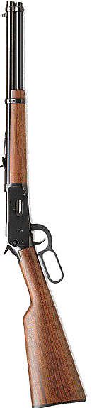
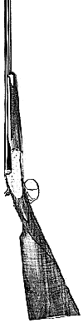
Shooter is standing at coffin. When ready say “Drinks are on me, amigo!” Wait for the beep. On the beep, draw PR pistol and engage each target twice. Dump magazine and ground pistol. Move to RH window and engage each Cowboy rifle target twice. Make rifle safe. Move to doorway, activate the Swingin’ Cowboy and engage 5 times with Cowboy pistol. Holster. Move to LH window. Alternate 5 rounds on the PR rifle targets. Make rifle safe. With shotgun engage the 6 swinger plates once each. Make shotgun safe.

S S S P

S3

P



