PROFESSIONALS STAGE 3
10 PR PISTOL 5 PR RIFLE 5 COWBOY PISTOL 9 COWBOY RIFLE 5 SHOTGUN
PR pistol loaded with 5, holstered, plus 5 round reload.
PR rifle loaded with 5, staged at RH window.
Cowboy pistol loaded with 5 rounds holstered.
Cowboy Rifle loaded with 9, staged at RH Window.
Shotgun loaded with up to 5 rounds, staged at LH window.
This village is crawlin’ with Federales. But the Padre says you’re safe in the church. Somebody needs to tell the Federales.

PR Rifle PR Rifle


Cowboy Rifle

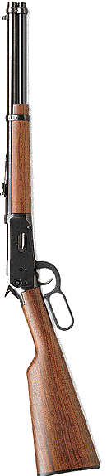
Shooter is standing at doorway. When ready say “Sanctuary!” Wait for the beep. On the beep, activate the Swingin’ Cowboy and engage 5 times with PR pistol. Dump magazine and move to LH window. Reload PR pistol and Nevada Sweep the bottom swinger plates. Dump magazine and ground pistol. With shotgun, Nevada Sweep the bottom swinger plates. Make shotgun safe. Move to RH window and Nevada sweep the Cowboy rifle targets. Make rifle safe. Engage the PR rifle targets 5 on 2. Make rifle safe. Move to coffin. Draw Cowboy pistol and engage each pistol target once. Holster.

S/P S/P S/P P

S3

P

