PROFESSIONALS STAGE 2
10 PR PISTOL 5 PR RIFLE 5 COWBOY PISTOL 10 COWBOY RIFLE 6 SHOTGUN
PR pistol loaded with 5, holstered., plus 5 round reload.
PR rifle loaded with 5, port arms at RH window.
Cowboy pistol loaded with 5 rounds holstered.
Cowboy Rifle loaded with 10, staged at LH Window.
Shotgun loaded with up to 6 rounds, staged at RH window.
You made it to Vera Cruz with the Contessa and the gold. It’s payday!

PR rifle PR Rifle

Cowboy Rifle

SG
SG

PR Pistol Cowboy Pistol
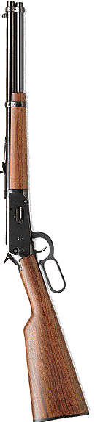
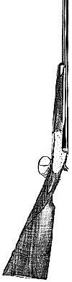

Shooter is standing at RH window with PR rifle at port arms. Signal readiness by saying, “One million’s enough for me!” Wait for the beep. On the beep, triple tap one rectangle and double tap the other. Make rifle safe. Engage the 6 shotgun targets once each. Make the shotgun safe. Move to doorway. With Cowboy pistol, shoot the falling plates until all are down. Shoot all remaining rounds on the dump plate. Holster and move to LH window. With Cowboy rifle, do a double tap Nevada Sweep on the circles, make rifle safe. Draw PR pistol and double tap the 5 targets. Dump magazine and ground pistol.
Standing falling plates are counted as misses, as are any misses of the dump plate.

