PROFESSIONALS STAGE 1
10 PR PISTOL 5 PR RIFLE 5 COWBOY PISTOL 9 COWBOY RIFLE 6 SHOTGUN
PR pistol loaded with 5, holstered., plus 5 round reload.
PR rifle loaded with 5, staged at LH window.
Cowboy pistol loaded with 5 rounds holstered.
Cowboy Rifle loaded with 9, staged at RH Window.
Shotgun loaded with up to 6 rounds, staged at RH window.
These gringos are uncouth. This well-armed drunkard spills more wine than he drinks.

PR rifle PR Rifle

Cowboy Rifle

SG
SG

PR Pistol Cowboy Pistol
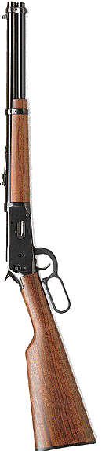
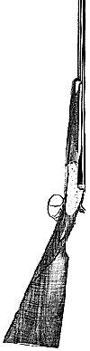

Shooter is standing at LH window holding wine glass in strong hand. Signal readiness by saying, “Careful, some of that wine is getting in your mouth!” Wait for the beep. On the beep, set down the glass, draw PR pistol and sweep the 5 targets twice, no double taps. Dump magazine and ground pistol. With PR rifle, alternate 5 rounds on the rectangles. Make rifle safe. Move to doorway. With Cowboy pistol, shoot the falling plates until all are down. Shoot all remaining rounds on the dump plate. Holster and move to RH window. With Cowboy rifle, sweep the circles three times (no double taps). Make rifle safe. Engage the 6 shotgun targets once each. Make the shotgun safe.
Standing falling plates are counted as misses, as are any misses of the dump plate.

