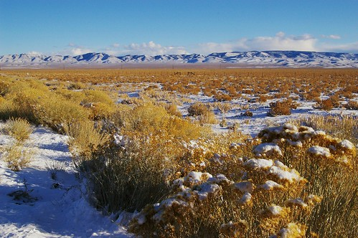 THE VIGILANTE 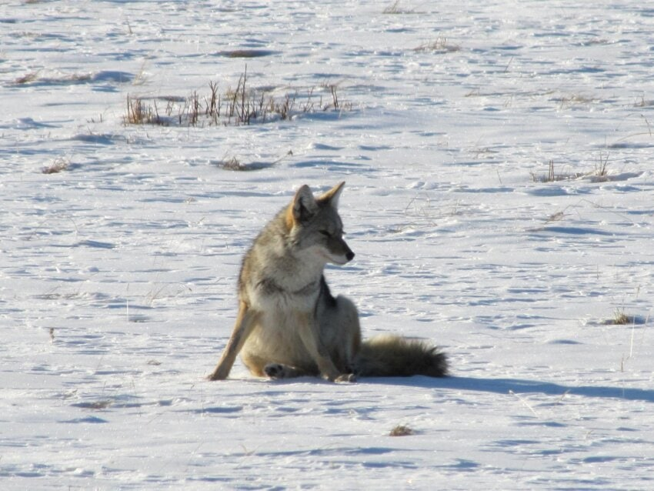
Volume 26 Issue 1 Editor: Nasty Newt SASS # 7365 Winter 2024

The Quarterly Chronicle of the Robbers Roost Vigilantes
From the President
Robbers Roost Gap
We built our range back around the turn of the century. That still sounds funny. To me, “the turn of the century” had always meant 1900, and I suppose it always will. But, I must admit Y2K was quite the adventure, with predictions of utter chaos due to the fact that all the world’s computers would think it was 1900, not 2000, and if the world didn’t end, it wouldn’t miss it by much. A friend of mine spent New Year’s Eve in the RV park at Stovepipe Wells in Death Valley. He said he didn’t know exactly why, just that he would feel better out in the middle of nowhere when it all came crashing down.
Now that I’ve told that story, what were we talking about? Oh yeah, the construction of the RRV range. Well, anyway, there was a minimum back berm height. I think the bull dozer had broke down, and the front end loader on the RGRA’s backhoe wouldn’t reach high enough. I know, because one day I tried to add dirt to the berm, but the only thing I added dirt to was me. Coso Kid and Kazarah Jane found, and we hired, a guy with a BIG tractor that made the Case look like a toy, and he finished the back berm and also worked on the north berm, which at that time was the extent of our range.
I always thought it was ironic that the Robbers Roost Vigilantes couldn’t see Robbers Roost from our range because of the berms. But, as I learned at our match on January 20th, we can see it. I just happened to be loitering at the right edge of the Open Range bay, from where I scanned the berm. There is a notch where the tall back berm intersects with other berms, and in that gap, basking in a ray of sunshine on that cloudy day, was our namesake!
I excitedly pointed it out to the rest of the guys. I’m not sure if, like me, they had never noticed it, or if they were just humoring me. But, at least nobody said, “No shit, Sherlock.” 😊
Continued on page 2

BOTH COWBOY SIDES NOW
By Nasty Newt, SASS 7365
With Apologies to Joni Mitchell
Lying on a bedroll flat, then “Beep” jump up, put on my hat. Shoot underneath a horse’s neck, I’ve shot a stage that way. But now we mostly cycle guns, and playing cowboy’s rarely done. The game has changed, but what the heck, my knees like it this way. I’ve looked at CAS from both sides now, from young and old, and still somehow, it’s CAS illusions I recall. I really don’t know CAS, at all.

Western movies, TV shows, ivory grips, six big fat holes. A backstrap labeled, “Nasty Newt,” I’ve looked at Colts that way. But now my Colts are acting strange, once in a while, one won’t go bang. I’ve heard you can’t slip hammer Colts, I may have found a way. I’ve looked at Colts from both sides now, from want and have, and still somehow, it’s Colt’s illusions I recall. I really don’t know Colts, at all.

Hell on Wheels, the John Wayne Shoot, Nevada’s annuals were a hoot. The Cal State match, and Showdown, too, I’ve looked at SASS that way. But now I only shoot right here, can’t see too well, I cannot hear. And it’s a cinch to haul my gear, it's just twelve miles each way. I’ve looked at SASS from both sides now, from far and near, and still somehow, it’s SASS illusions I recall. I really don’t know SASS, at all.
Continued on page 2

INSIDE THIS EDITION
1 From the President 2 Board of Directors
1 Both Cowboy Sides Now 3 Business Cards
2 Robbers Roost Gap 3 The Surplus Gun ‘riter
r
2 Upcoming Events

Information
4 Where is “Why the West Was Won” ?

Both Cowboy Sides Now continued from page 1
Crotch holsters and shell belt bras, two strong side holsters, Ohmygod! “If it doesn’t say I can’t, I can.” We’ve looked at rules that way. But the Wild Bunch thought this looked horse s**t, and wrote some rules to outlaw it. Though they were right, rule books abound, with countless rules in play. I’ve looked at rules from both sides now, from can and can’t, and still somehow, it’s rules illusions I recall. I really don’t know rules, at all.
A four-day bash, Defend the Roost, Just George gave our club a boost. I sang and ate, and drank too much, I’ve DTR’d that way. Now worker bees are getting tired, a bunch have quit, moved, and retired. The Yelping Coyote Saloon is dry, the big tent has had its day. I’ve defended the roost from both sides now, from “Yes, we can” to “Can’t see how,” but it’s Roost illusions I recall. I don’t know Defend the Roost, at all.
One posse, or maybe two, there was a time we had to choose. “The World’s Fastest Growing Shooting Sport,” they stood in line to pay. But now we shoot with less than ten, and no one’s clamoring to get in. The growth has come, the growth has gone. I think it’s gone to stay. I’ve looked at growth from both sides now, from boom and bust, and still somehow, it’s growth’s illusions I recall. I really don’t know growth, at all.

(Guitar fades out)

From the President Continued from page 1

The Christmas match went well. Thanks to everybody that brought side dishes and prizes for the table, and to Wrangler Red and his elf, ZigMar, for doing a great job with the door prizes, as they always do. Thanks to Desert Willow for buying and bringing out the Kentucky Fried Chicken, and for dressing up the tables, and to Cowboy Earl for grilling brats. And thanks to everybody that worked to make it a success. It takes a lot of effort and I am always proud of the way it all comes together.

Robbers Roost Vigilantes
Executive Board
President
Nasty Newt
Vice President
Bad Bascomb
Secretary
Goode Bascomb
Treasurer
Desert Willow
Territorial Governor/Webmaster
M. C. Ryder
Range Officer/Sgt. at Arms
Cowboy Earl
Match Director Emeritus
Just George
The Robbers Roost Vigilantes Executive Board and the editor of The Vigilante are not responsible for mishaps of any nature that might occur from the use of published loading data or from the recommendations by any member of the staff, guest writers, or from products sold by advertisers.

The first person of European descent to see Robbers Roost Gap is believed to be Nasty Newt, in the winter of ’24. Although his admirers wanted to name the feature “Newt’s Notch,” he humbly declined, stating, “The world will little note nor long remember what I discovered here, but we must never forget what those storied cut-throats and highwaymen did here.”
Visitors can access the area from the east via RGRA Flat and the Robbers Roost toll road, or from the northern Smoke Pole region through Cowboy Earl Pass. NOTE: Extreme caution should be exercised when passing through El Pueblo de Los Emigrantes. Duelin’ Tom, known as El Jefe in the Pueblo environs, has designated the area as a sanctuary pueblo, and it is teeming with asylum-seeking thieves, murderers, and horse jackers.
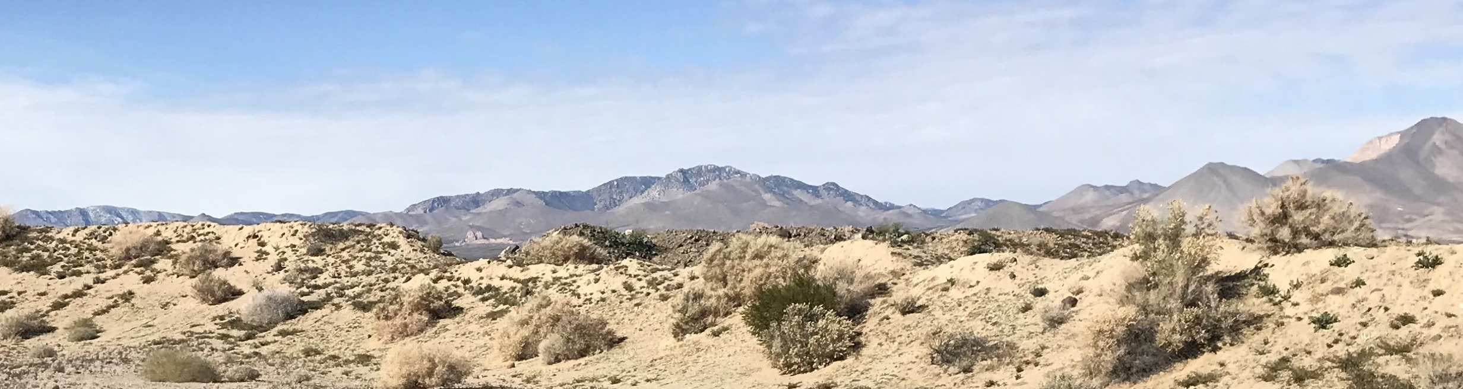

Business Card Advertising
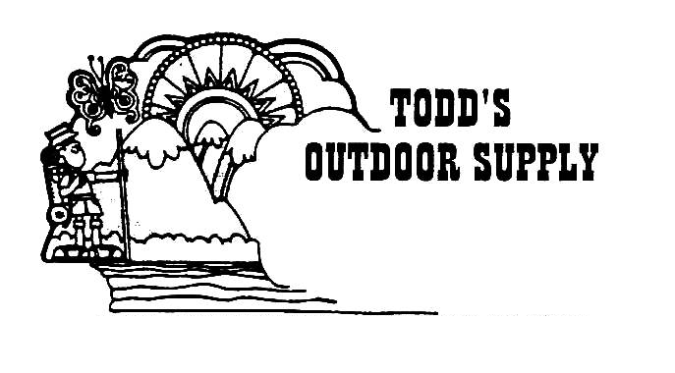

BAD BASCOMB SASS #47,494
(aka MARI TODD)


NAME BRANDS TO SURPLUS
QUALITY CLOTHING & EQUIPMENT
FOR TRAIL OR TRAVEL
(760) 375-7223
How to Join the Robbers Roost Vigilantes…
Come out to a RRV match, held the third (and sometimes first) Saturday of every month, or call Nasty Newt at 760-375-7618, or MC Ryder at 760-384-2321, or mail it in. Our membership application is here RRV Membership Application Annual membership dues for the RRV are: single membership $25, member and spouse $30, family membership (including children under 18 living at home) $35. First time shooters will be able to take their FIRST (1) NEW SHOOTERS CLASS for $10, any subsequent new shooters class or RRV match shoot will be $10 members, $15 nonmembers. Donations for shooting regular monthly RRV matches will be $10 members, $15 non-members. Memberships run from September 1 - August 31. New memberships purchased after September will be prorated depending on the number of months remaining and the type of membership. RRV members are encouraged to become Single Action Shooting Society (SASS) members. Please call SASS at 877-411-SASS. SASS membership information can be found here:
http://www.sassnet.com/Membership-Main-001A.php

SASS membership is not required for membership in RRV, or participation in RRV regular monthly matches. RRV encourages all shooters to join and support the NRA and the NRA Foundation, and Ridgecrest Gun Range Association. For further information visit our website at www.robbersroostvigilantes.com.

Note: Both GUNS4US and KZGN TV are at a new location at
409 S. China Lake Blvd, Ridgecrest, CA. 93555

Schedule of Monthly Matches
Matches are announced on the web site and via email to club members. Cowboy matches are first (sometimes) and third Saturday. Usually, Trail Walks are second Saturday, and BAMM and Cowboy Rifle are fourth Saturday, when scheduled.
Winter Hours: Sign up around 8:00, Meeting around 8:45.

The Surplus Gun ‘riter
Wherein is Dispensed Expert Analysis of Vintage Fireams and Militaria
The 11mm French Mle 1874 Gras Fusil single shot bolt action rifle was adopted by the French military to replace the 1866 Chassepot (shas-poh) needle gun, which was the standard French rifle during the Franco-Prussian War of 1870-71. Although the Chassepot was superior to the Dreyse needle gun fielded by the Germans, the French went ahead and lost the war anyway. Many Chassepots were subsequently converted to the Gras system which fired a metallic cartridge. The author’s example has some improvised parts, and is missing other parts altogether. The stock shows minor cracks, dings, and trench art, but, he states, “All in all, she’s in fair shape for a Royal Tiger Imports C Grade gun that spent the last 80 years in a goat shed in Ethiopia.” Below, The Surplus Gun ‘riter demonstrates proper loading technique for the Mle 1974 Gras, which requires considerable manual dexterity but can be mastered with practice.
