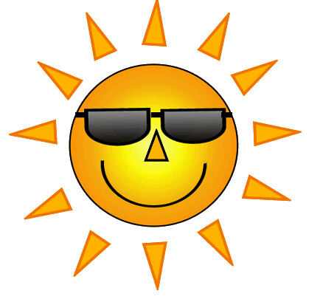 THE VIGILANTE 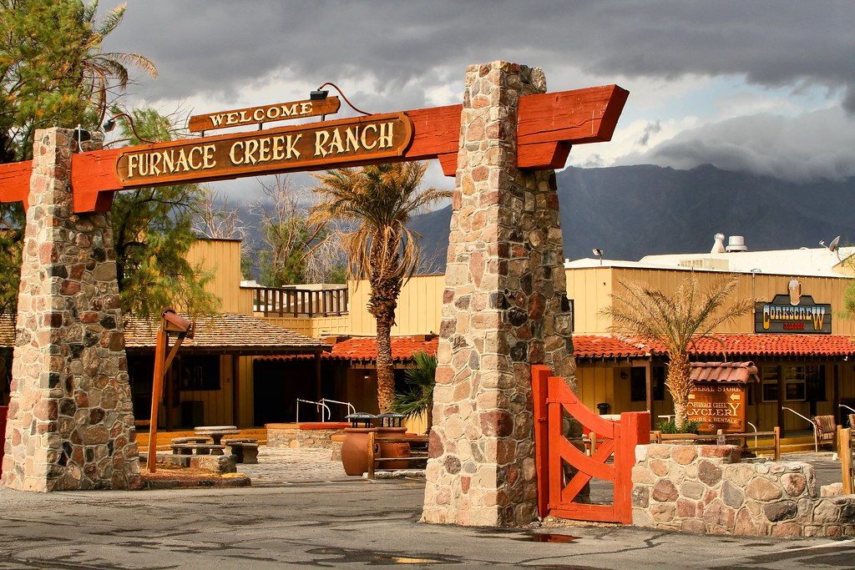
Volume 25 Issue 3 Editor: Nasty Newt SASS # 7365 Summer 2023

The Quarterly Chronicle of the Robbers Roost Vigilantes
From the President
Shoot-em-up Movies Make Comeback
At RRV Range
As some of you know, Jayne Cobb has been producing videos of RRV matches. He’s pretty darn good at it, and if you haven’t watched any of them, you should. I sometimes insert what I consider to be great witticisms in place of the shooter line. So far I’ve only made one off-color comment that got recorded, and it was a while ago and probably won’t come back to haunt me. I have had my hot mic epiphany. It still feels a little strange to hear the R.O. say, “Quiet on the set” before saying “Stand by,” but I’m getting used to it.
Knowing that there is a digital device called Auto-Tune that is employed in recording studios to repair the efforts of off-key singers and musicians, I asked Jayne Cobb if there was an Auto-Slim device that could be incorporated into video cameras. Of course, I was asking for a friend, but it turns out Auto-Slim is still a few years away, and I’m not sure my friend can hold his belly in for 40 seconds.
Jayne Cobb made a video of the July 15 match. He also worked posse chores, even though he didn’t shoot. Thanks again. J.C. It was much appreciated. Here is a link in case you haven’t seen the video. https://www.youtube.com/watch?v=C1_sFxAkokw
Speaking of that match, as advertised, it was a hot day, I think the hottest day of the year so far. But with only six shooters and fast stages, we were done early, around 9:30. I think M.C. Ryder’s stages were darn near perfect for the occasion. Each stage dropped either the rifle, pistols, or shotgun out of the scenario. They were great fun to shoot, and nobody felt short-changed because they didn’t get to pull the trigger 24 times on each stage. Thanks, M.C., for everything you do.
M. C. Ryder and I are the only two people still shooting who have an “F” in front of our RRV badge number. The “F” stands for founder. I’m happy to have been associated with him from the RRV’s beginnings.
Continued on page 2

WHO WANTS TO BE A MILLIONAIRE COWPERSON?
A Wild West Quiz
by Nasty Newt Sass # 7365

A young Roy Rogers got his show biz start singing with what group?
- The Beatles
- Sons of the Pioneers
- Slye and the Family Stone
- The Sex Pistols

Roy Rogers’ real name was
A. Archibald Leach
B. 50 cent
C. Leonard Slye
- Sly Stone

Who said, “I won’t be wronged, I won’t be insulted, I won’t be laid a hand on. I don’t do these things to others and I require the same of them.”
- J.B. Books
- J.R. Ewing
- K.D. Lang
- Rodney King

John Wayne’s signature line in The Searchers was
- “You’re not the boss of me.”
- “We may find her, we may not.”
- “You’ll find that Comanches are good-hearted people once you get to know them.”
- “Cain’t we all……..git along?”
- “That’ll be the day.”
- “I wish I knew how to quit you.”

Continued on page 2

INSIDE THIS EDITION
1 From the President 2 Board of Directors
1 Wild West Quiz 3 Business Cards

2 Upcoming Events

Information
4 Where is “Why the West Was Won” ?

Millionaire continued from page 1
A “free-spin Pawl” is
- A guy named Paul who got lucky on Wheel of Fortune whose mother couldn’t spell.
- What’s left of your ratchet after some gorilla uses it for a breaker bar.
- A pathetic attempt to turn a Ruger into a Colt.
Now used to describe a firearm modification, the term “short stroke package” originally referred to
  - Duelin’ Tom
  - Just George
  - M.C. Ryder
  - Wrangler Red
  - All of the above
A Henry rifle is
  - Beautiful
  - A replica of nothing
  - Depends on which one you’re talking about
  - I thought his name was O Henry
Which of the following sounds more manly?
- Plink-tink
- Bang-clang
- “Honey, where’s the remote?”
Who said, “If anything goes wrong—my fault, your fault, nobody’s fault—the boy dies.”
- Richard Boone, to John Wayne in Big Jake, referring to John Wayne’s kidnapped grandson.
- Prince Phillip, to Queen Elizabeth, referring to Prince Charles.
- Bill Clinton, to Hillary Clinton, referring to George Stephanopalous.
- Tex, to Black Jack Traven, referring to Badlands Bud continued

From the President Continued from page 1

Cowboy Earl is looking at putting on a muzzle loader trail walk on July 29, which would fall into the “unless otherwise announced” category, since we typically do those on the second Saturday. It will be announced via email if it comes to fruition.

The next BAMM/Cowboy 3 Rifle shoot will probably be this fall. Those matches can be strenuous, as most of us usually have to wrestle with our rifles on a stage or two. Cooler weather is better for rifle wrestling.

Robbers Roost Vigilantes
Executive Board
President
Nasty Newt
Vice President
Bad Bascomb
Secretary
Goode Bascomb
Treasurer
Desert Willow
Territorial Governor
M. C. Ryder
Range Officer/Sgt. at Arms
Cowboy Earl
Match Director Emeritus
Just George
The Robbers Roost Vigilantes Executive Board and the editor of The Vigilante are not responsible for mishaps of any nature that might occur from the use of published loading data or from the recommendations by any member of the staff, guest writers, or from products sold by advertisers.

In 1966 a young Burt Reynolds played an Indian in a spaghetti western called
- Apache Andy
- Sioux City Sioux
- Navajo Joe
- Nez Perce Percy
In Pale Rider, Clint Eastwood played
- A preacher
- A ghost
- A gunfighter
- The accordion
- Shane
- A,B,C & E
In Open Range, Kevin Costner gets
- Involved in some sort of weird “dead dog, living dog” parable
- Really ticked off and starts fanning his high capacity revolver
- Warren Beatty’s wife
- An acting lesson from Robert Duval
- All of the above continued
In High Plains Drifter, Clint Eastwood played
- A ghost
- A gunfighter
- A former lawman
- The triangle
- A, B, & C
In Tombstone, Doc Holliday says, “I have two guns, one for each of you” to
- Cheech and Chong
- Dolly Parton
- Ike and Ike Clanton
- Bill and Hillary Clinton

Business Card Advertising
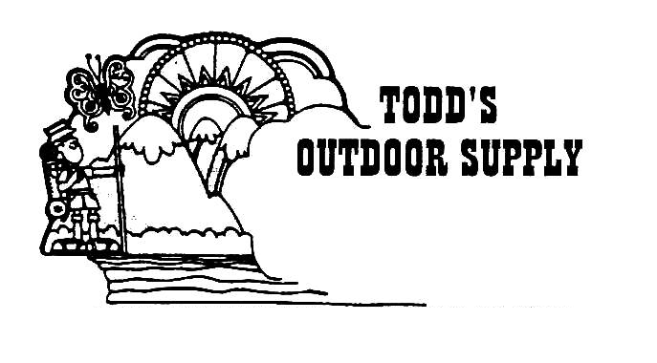

BAD BASCOMB SASS #47,494
(aka MARI TODD)

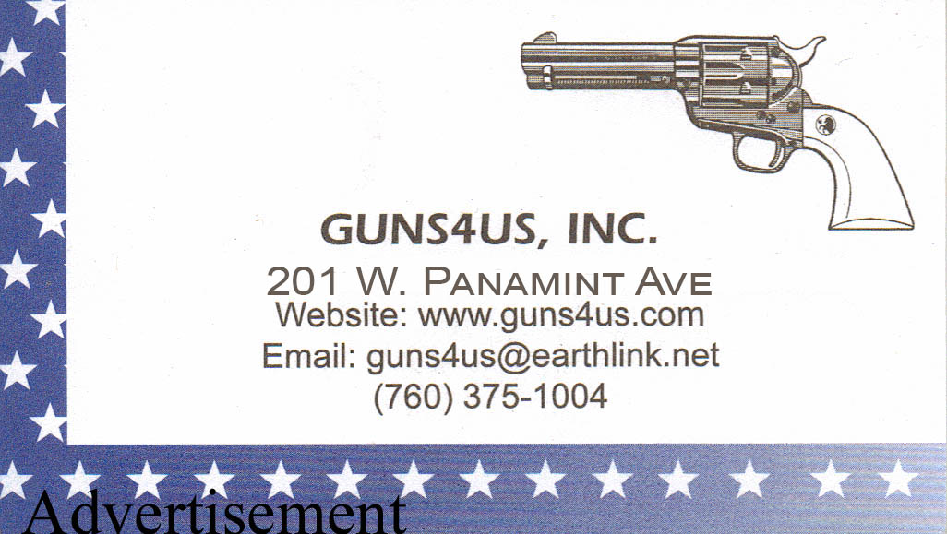
NAME BRANDS TO SURPLUS
QUALITY CLOTHING & EQUIPMENT
FOR TRAIL OR TRAVEL
(760) 375-7223
How to Join the Robbers Roost Vigilantes…
Come out to a RRV match, held the third (and sometimes first) Saturday of every month, or call Nasty Newt at 760-375-7618, or MC Ryder at 760-384-2321, or mail it in. Our membership application is here RRV Membership Application Annual membership dues for the RRV are: single membership $25, member and spouse $30, family membership (including children under 18 living at home) $35. First time shooters will be able to take their FIRST (1) NEW SHOOTERS CLASS for $10, any subsequent new shooters class or RRV match shoot will be $10 members, $15 nonmembers. Donations for shooting regular monthly RRV matches will be $10 members, $15 non-members. Memberships run from September 1 - August 31. New memberships purchased after September will be prorated depending on the number of months remaining and the type of membership. RRV members are encouraged to become Single Action Shooting Society (SASS) members. Please call SASS at 877-411-SASS. SASS membership information can be found here:
http://www.sassnet.com/Membership-Main-001A.php

SASS membership is not required for membership in RRV, or participation in RRV regular monthly matches. RRV encourages all shooters to join and support the NRA and the NRA Foundation, and Ridgecrest Gun Range Association. For further information visit our website at www.robbersroostvigilantes.com.

Note: Both GUNS4US and KZGN TV are at a new location at
409 S. China Lake Blvd, Ridgecrest, CA. 93555

Schedule of Monthly Matches
Matches are announced on the web site and via email to club members. Cowboy matches are first (sometimes) and third Saturday. Usually, Trail Walks are second Saturday, and BAMM and Cowboy Rifle are fourth Saturday, when scheduled.
Summer Hours: Sign up starting ~ 7:00, Safety Meeting ~ 7:45.

In High Plains Drifter, Clint Eastwood played
- A ghost
- A gunfighter
- A former lawman
- The Jew’s harp
- A, B, & C
In Tombstone, Doc Holliday says, “I have two guns, one for each of you” to
- Cheech and Chong
- Dolly Parton
- Ike and Ike Clanton
- Bill and Hillary Clinton
You win $1.00 for every correct answer. Submit your answers to Nasty Newt, the RRV Quizmaster, for official scoring, along with $25.00 in cash or money order to partially offset the cost of administering the contest. The $25.00 fee is non-refundable. The Quizmaster will let you know how many you got right and your check will be in the mail. Prize checks will be drawn on the West Bank of Goler Wash. Decisions of the Quizmaster are final. No whining. It’s The Cowboy Way.

