 THE VIGILANTE 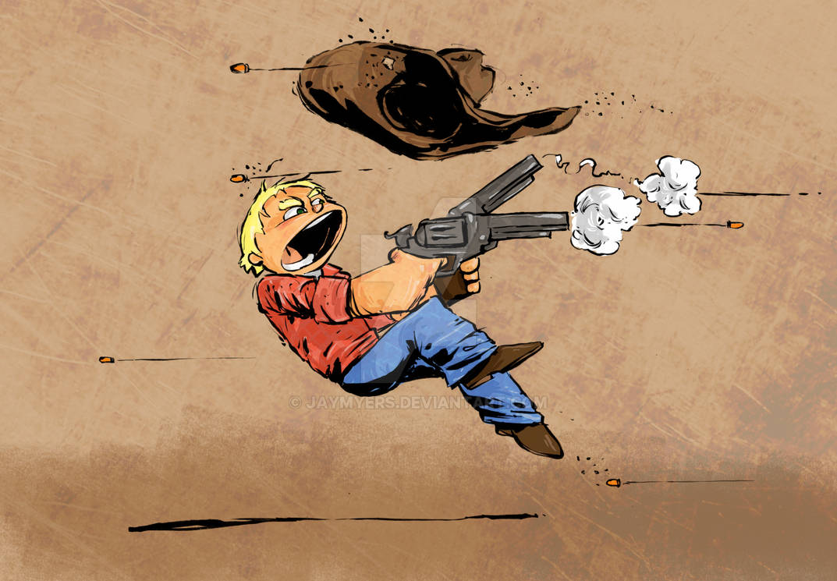
Volume 24 Issue 4 Editor: Nasty Newt SASS # 7365 Summer 2022

The Quarterly Chronicle of the Robbers Roost Vigilantes
From the President
You Don’t Have to be Hard-Core to Shoot in the Summer
But Those Who Do Usually Are
Seven of us made it out to the range on July 16. Most of us were of the hard-core variety. Maybe I should say hard-headed. What I mean by hard-core is a shooter who has been at it quite a while, feels that Cowboy Action Shooting is a significant cog in the machine of life, and is often determined to shoot a match even when fear and common sense are suggesting otherwise.
“Been at it quite a while” implies the passage of time, and it just keeps on passing, picking up speed as it goes. So, there we were, looking, with a couple of exceptions, like residents of The Home out on an unsupervised field trip, slinging lead. We all knew it would be hot, and decided to do it anyway. Common sense is the second thing to go.
In a way, the RRV is a microcosm of SASS. SASS has issued something like 110,000 badge numbers, but a few years ago Misty Moonshine let slip the fact that there are about 20,000 dues-paying members, and a few thousand more life members whose contributions to the SASS kitty ended years ago. SASS is graying at the temples, with most members shooting as Seniors or above.
In 2005, the RRV had 77 members. The current spreadsheet has less than 30 names on it, and about half rarely if ever shoot. Luckily, we decided early on to not offer life memberships, so we are okay financially. Like SASS, the majority of our members are over 60.
A young fellow drove up and watched us shoot the last stage on the 16th. Several of us spoke with him, and I invited him to join us on the patio when we were done. Ryan spent a lot of time with him, so he knew we weren’t all a bunch of bent-over, limping geezers, but he left anyway. 😊
Continued on page 2

Local Boy Makes Good
By
Nasty Newt, SASS # 7365
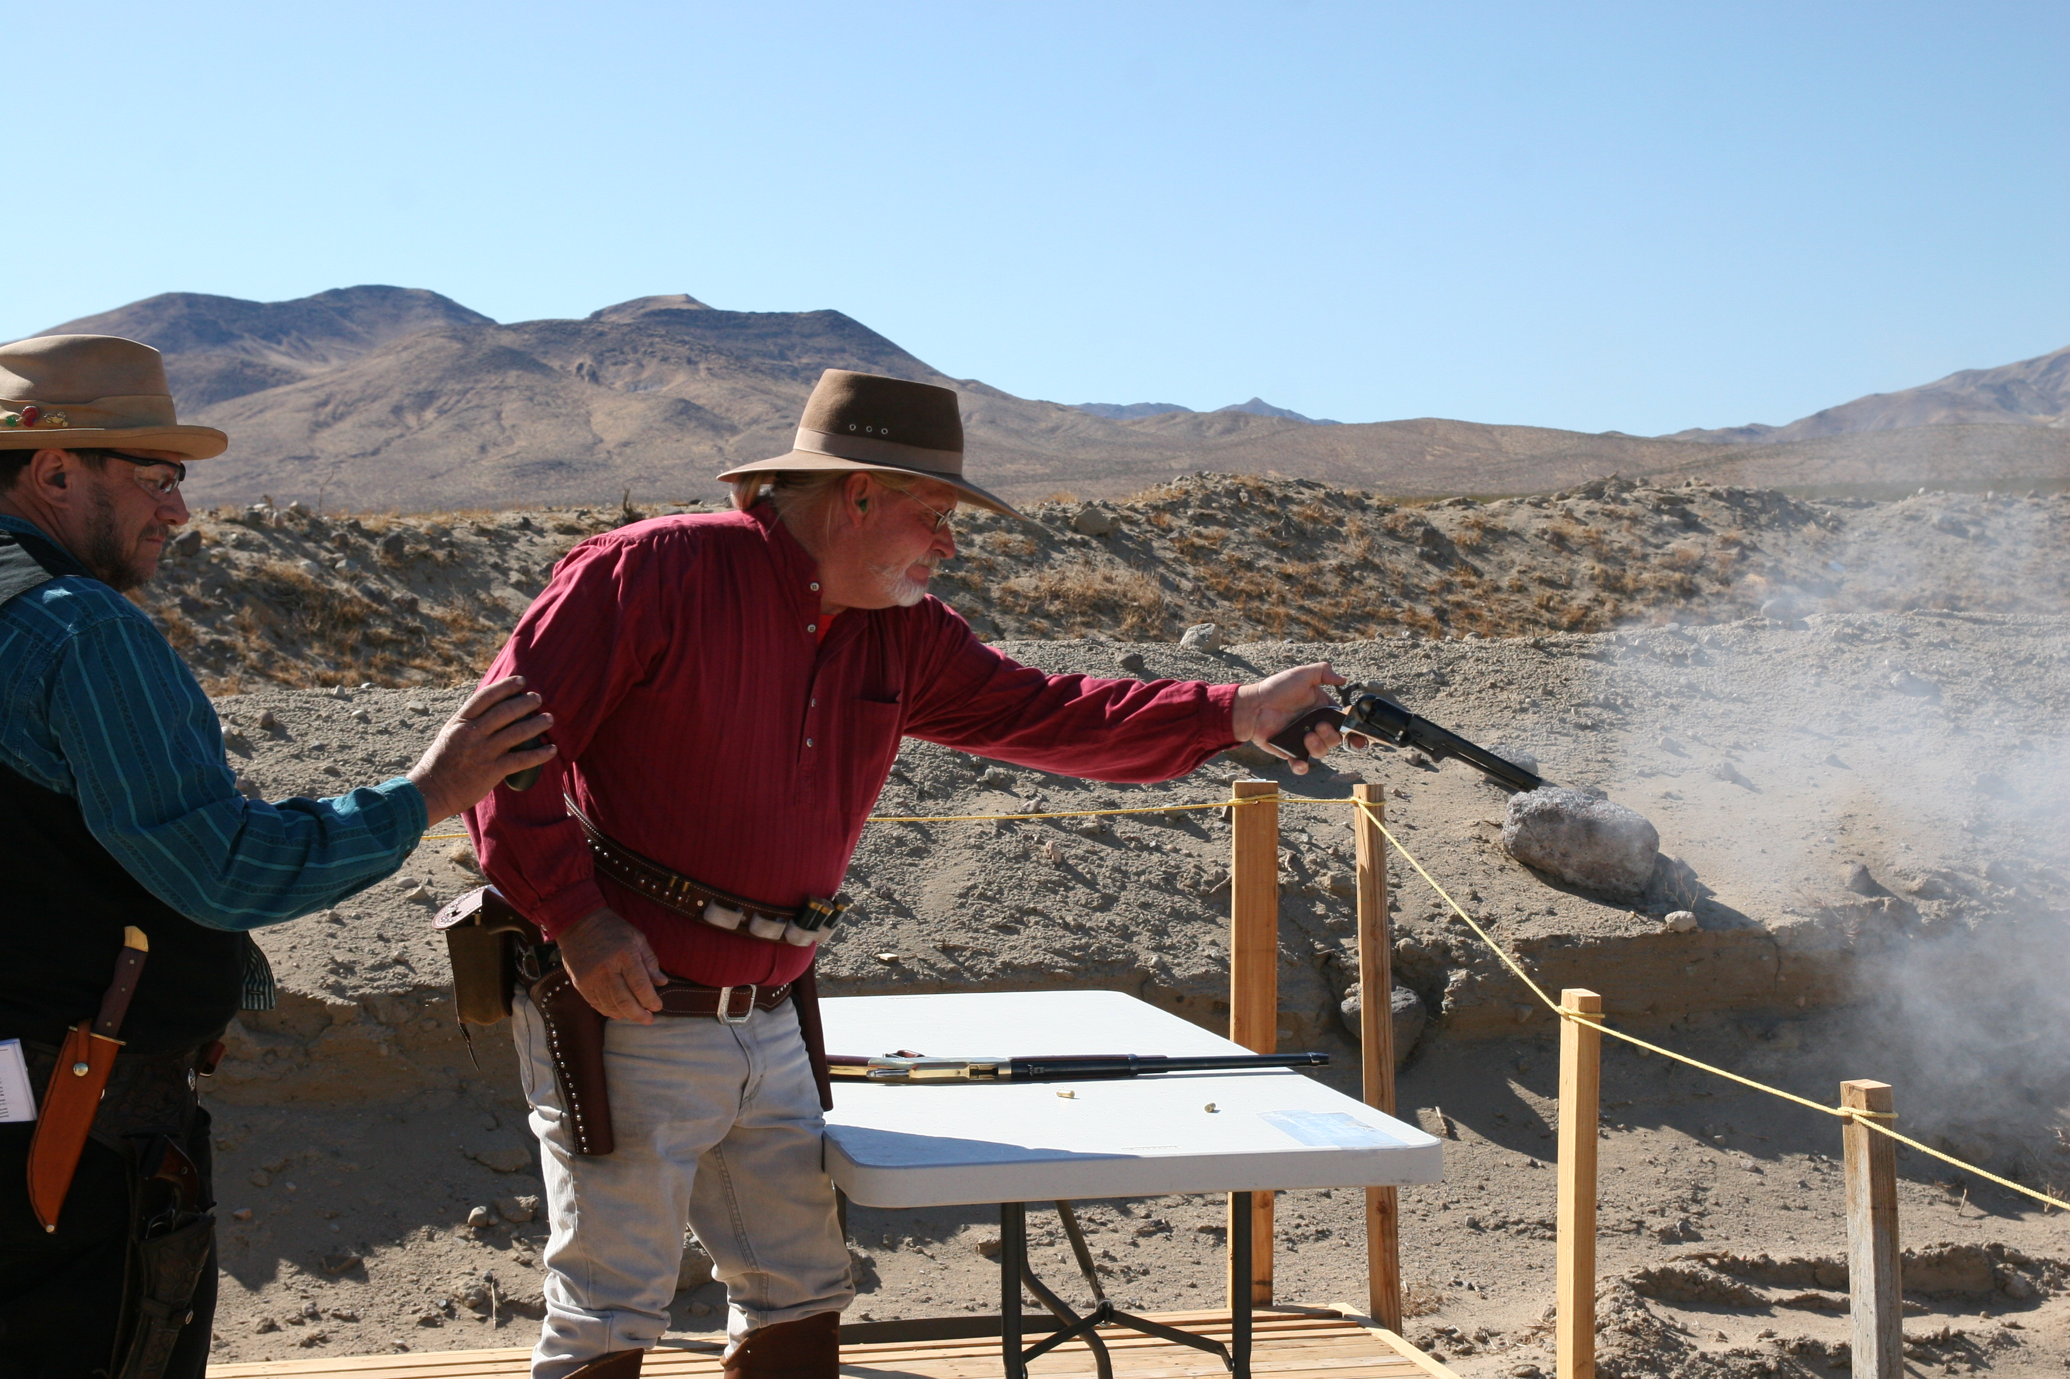
Cowboy Earl Makin’ Smoke at Defend the Roost 2011
Cowboy Earl, SASS # 61595, RRV # 110, joined SASS on October 25th, 2004, and on November 20th of that year, he signed on with the Robbers Roost Vigilantes. And in April of 2022, he shot his way to the SASS California State Frontier Cartridge Gunfighter Championship.
When asked about his experience with Cowboy Action Shooting, he said, “I got interested in the game through a fellow shooter who left the game shortly after I joined. Go figure.”
“After my first shoot I was hooked, and I’m still hooked today. After joining I soon figured out this game is not cheap, but I’ve been able to enjoy the game because I can do a lot of the work needed to compete. I went to trade school to learn leather work. I make my own leather and have done leather work for others. I build my own gun carts, and have built them for others, plus I made one for the club to raffle off for a Defend the Roost fund raiser. My jail wagon gun cart, the Hang ‘em High, placed third at EOT 2015. I also do my own gunsmithing, learned that by trial and error.”
Continued on page 2

INSIDE THIS EDITION
1 From the President 3 Goode Bascomb State Champ
1 Cowboy Earl State Champ 3 Business Cards
3 Match Schedule

2 Upcoming Events

Information
4 Where is “Why the West Was Won” ?

Cowboy Earl continued from page 1
Cowboy Earl has been a RRV worker bee from the start. Several years ago, after Kazarah Jane and Coso Kid had moved on to Utah, he asked me if I was happy with our sets. At the time we had two: The Depot, which was a Cowboy Earl project, and the Church/Cemetery, which Gravedigger had designed. I liked them both, so I said, “Sure.” He said, “Okay, then.” Eventually I figured out he was asking if I would like more sets, so I revised my answer to, “Heck yeah” and he was off and running. In due time, along came the Hotel, the Saloon, and the Pueblo, and most recently the O.K. Corral. And although it galls me that we had to do it, I’m glad we had a metal worker and welder who could tweeker-proof the locks on the sea vans. Range Master Cowboy Earl to the rescue.
Did I mention the hot dogs? Another reason for being glad to see fall and winter arrive is hot dogs. We don’t have them every match, but we all look forward to those get-togethers at the cantina when Cowboy Earl fires up the grille.
Did I mention the muzzle loaders? A few years ago, Cowboy Earl said, “You know, I could set up a Trail Walk range over there on the North 40.” And he did. Talk about fun. We spend as much time ragging each other as we do shooting, and if you’re wondering, it is by far the least expensive to get into and to shoot of all the things we do at the RRV. Cowboy Earl also came up with Cowboy 3 Rifle, another great idea that we do, usually as part of a BAMM match.
He said, “This game has brought me lots of enjoyment (and expense) through the years but I wouldn’t change it for anything. Sometimes I think the game keeps me going. SASS is fading, with the Wild Bunch stepping down, and new people taking over, bringing new rules and new ideas. For me, change isn’t always good, but I’ve loved the sport for eighteen years and will continue to enjoy it as long as I can.”

From the President Continued from page 1
Cowboy Earl stated earlier this year that there would be no more Trail Walks until Summer was done. There will also be no BAMM/3RIFLE matches until the Fall. Those cantankerous bolt actions can be a lot of work, especially when it’s hot, but I love shooting them. Hard-core is as hard-core does.

We decided to skip the first Saturday cowboy match in August, and I opined that if the third Saturday was as hot as July 16th, I probably wouldn’t shoot. But I probably will.

Robbers Roost Vigilantes
Executive Board
President
Nasty Newt
Vice President
Bad Bascomb
Secretary
Goode Bascomb
Treasurer
Desert Willow
Territorial Governor
M. C. Ryder
Range Officer/Sgt. at Arms
Cowboy Earl
Match Director Emeritus
Just George
The Robbers Roost Vigilantes Executive Board and the editor of The Vigilante are not responsible for mishaps of any nature that might occur from the use of published loading data or from the recommendations by any member of the staff, guest writers, or from products sold by advertisers.

https://www.youtube.com/watch?v=8YGjsWeyBmI

To watch videos of Cowboy Earl shooting the State
Match, click on the above link. If the link doesn’t
work, go to youtube and search for
SASS Maddog Mark D Cowboy Earl

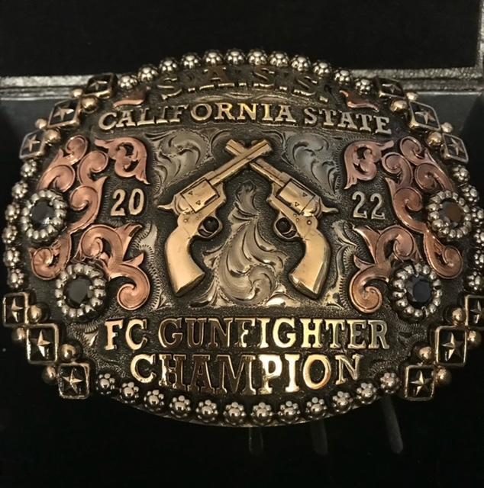

Business Card Advertising


BAD BASCOMB SASS #47,494
(aka MARI TODD)


NAME BRANDS TO SURPLUS
QUALITY CLOTHING & EQUIPMENT
FOR TRAIL OR TRAVEL
(760) 375-7223
How to Join the Robbers Roost Vigilantes…
Come out to a RRV match, held the third (and sometimes first) Saturday of every month, or call Nasty Newt at 760-375-7618, or MC Ryder at 760-384-2321, or mail it in. Our membership application is here RRV Membership Application Annual membership dues for the RRV are: single membership $25, member and spouse $30, family membership (including children under 18 living at home) $35. First time shooters will be able to take their FIRST (1) NEW SHOOTERS CLASS for $10, any subsequent new shooters class or RRV match shoot will be $10 members, $15 nonmembers. Donations for shooting regular monthly RRV matches will be $10 members, $15 non-members. Memberships run from September 1 - August 31. New memberships purchased after September will be prorated depending on the number of months remaining and the type of membership. RRV members are encouraged to become Single Action Shooting Society (SASS) members. Please call SASS at 877-411-SASS. SASS membership information can be found here:
http://www.sassnet.com/Membership-Main-001A.php

SASS membership is not required for membership in RRV, or participation in RRV regular monthly matches. RRV encourages all shooters to join and support the NRA and the NRA Foundation, and Ridgecrest Gun Range Association. For further information visit our website at www.robbersroostvigilantes.com.

Note: Both GUNS4US and KZGN TV are at a new location at
409 S. China Lake Blvd, Ridgecrest, CA. 93555


Schedule of Monthly Matches
Matches are announced on the web site and via email to all club members. Cowboy matches are first (sometimes) and third Saturday. Usually, Trail Walks are second Saturday, and BAMM and Cowboy Rifle are fourth Saturday, when scheduled.
SummerHours: Sign up starting ~ 7:00, Safety Meeting ~ 7:45.

Cowboy Earl isn’t the only RRV’er to bring home a State Championship title, nor the first. Goode Bascomb, SASS #53291, RRV #85, beat him to it by 14 years!

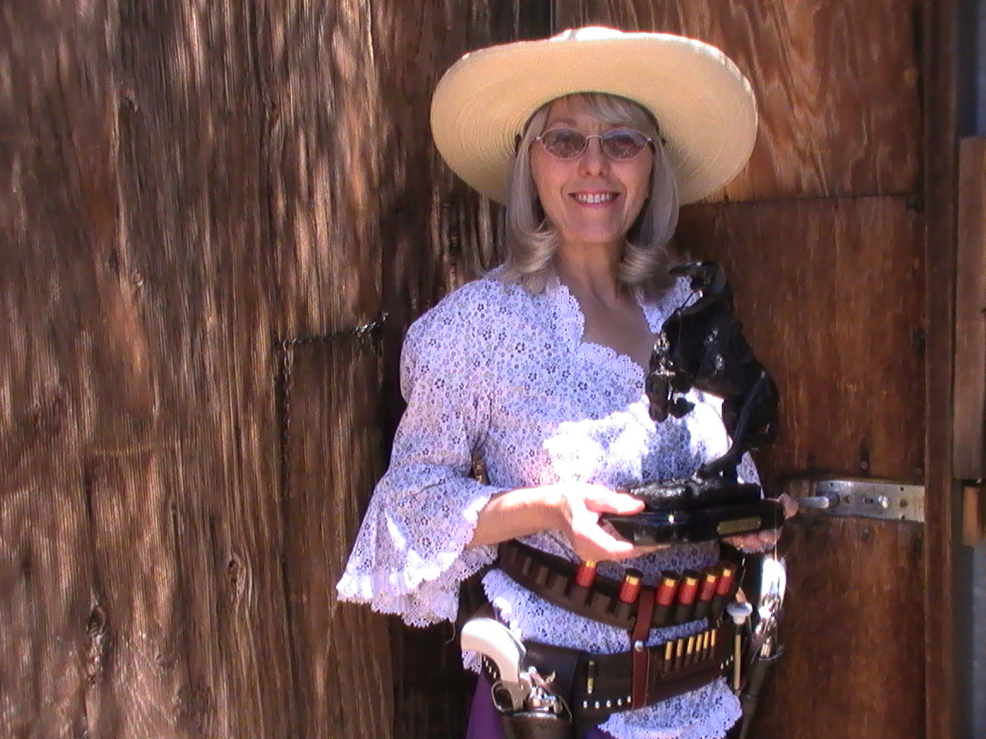
Goode Bascomb, California State Ladies Silver Senior SASS Champion for 2008

