 THE VIGILANTE 
Volume 22 Issue 4 Editor: Nasty Newt SASS # 7365 Summer 2020

The Quarterly Chronicle of the Robbers Roost Vigilantes
From the President
Back to Normal, Sort Of
Considering that we hadn’t shot a match in over two months, the match on May 16 went pretty well. As far as I know, nobody tried to put bullets in their gun backwards, and only a handful kept clicking their pistol after it was empty. But then again, some of us didn’t know how to count to five before the virus break, so that probably didn’t have anything to do with it.
Clubs all over the country went into hiatus over this thing. Some did so because the owner of the property where they shot demanded it, and some, like us, did it out of an abundance of caution. The Ridgecrest Gun Range Association never closed, and the RRV range has always been available to club members so long as social distancing is observed. End of Trail is cancelled, so you can’t accuse SASS and cowboy action shooters of not taking it seriously.
Businesses that are reopening, or are about to reopen, are seeking protection from lawsuits of the “You said it was okay for me to come to your store and I got sick so you owe me money” variety. Our country has become “sue happy” anyway, as more and more people take the position that if anything bad happens to them, it has to be somebody else’s fault, and that somebody owes them several million dollars. You know those lawsuits will be forthcoming. I hope the politicians figure out a way to protect businesses. Not to mention clubs.
So, barring some unforeseen development, it looks to me like we will probably have to keep doing things pretty much the way we did them on the 16th. For how long, nobody knows. As Death Valley Rose states in her article, we do want input from RRV members.
Six-foot social distancing isn’t all that hard to do. Having said that, I know I broke the barrier a time or two while running the timer, but I will improve. We all have to try to do it the best we can.
Continued on page 2

May 16, 2020
THE RRV SHOOTS AGAIN!
By
Death Valley Rose, RRV # 38
After much discussion, and Cowboy Earl doing in-person research with the RR Bar club, it was decided that some fresh air and exercise would go a long way towards curing “cabin fever” among the members of the Robbers Roost Vigilantes.

So a plan of action was made, we’d meet at the Range, wear masks, and observe the mandated distances.

The usual suspects, plus the newest Vigilante, the brilliantly named “Sir MissAlot” showed up ready for a long-awaited day in the sun.

A suggestion that we experiment with two small posses, thus cutting down the time spent in the heat, was approved. Nasty Newt and MC Ryder each led a group of seven valiant souls to their assigned stages, and the action began.

As hoped, the smaller than usual posses were fast! Where the full component of shooters would have finished the six stages around noon, the smaller ones were done shooting by a smidge past 10AM!

It turns out that, with only one person loading at a time, everyone working at whatever was needed - counting, timing, unloading, picking brass, scoring or helping with props, things went easily and swiftly. It was a bit chaotic at first, but soon settled into a routine of people doing those chores without needing reminding.

This way of shooting doesn’t work if people sit around gabbing, but leaves lots of time afterwards to “rag chew” and you get done before the worst of the heat.

Will we continue with the smaller posses? I suspect that will be another topic of discussion, so chime in if you have an opinion or three.

INSIDE THIS EDITION
1 From the President 3 Photos
1 RRV is Back 3 Match Schedule
2 Photos 3 Business Cards

2 Upcoming Events

Information
4 Where is “Why the West Was Won” ?

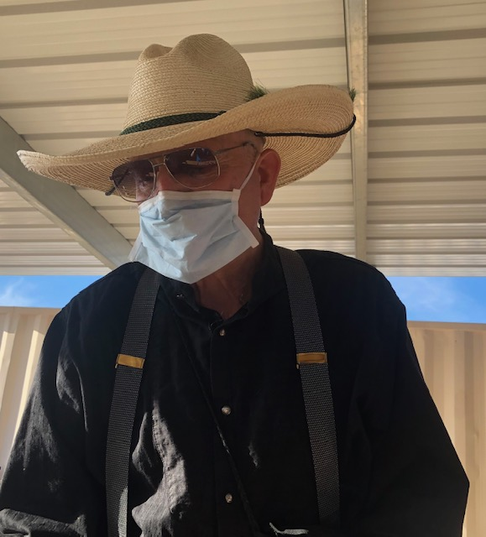

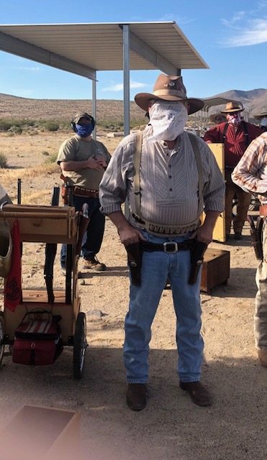

All photos courtesy of Death Valley Rose.
From the President Continued from page 1

I don’t know what the future holds. One expert says black, the next expert says white. I wish I didn’t think their opinions were politically motivated.

We’re on Summer Hours, so any matches announced will start signups around 7:00, and we’ll try to have the meeting by 7:45 unless otherwise announced.

Robbers Roost Vigilantes
Executive Board
President
Nasty Newt
Vice President
Bad Bascomb
Secretary
Goode Bascomb
Treasurer
Desert Willow
Territorial Governor
M. C. Ryder
Range Officer/Sgt. at Arms
Cowboy Earl
Match Director Emeritus
Just George
The Robbers Roost Vigilantes Executive Board and the editor of The Vigilante are not responsible for mishaps of any nature that might occur from the use of published loading data or from the recommendations by any member of the staff, guest writers, or from products sold by advertisers.

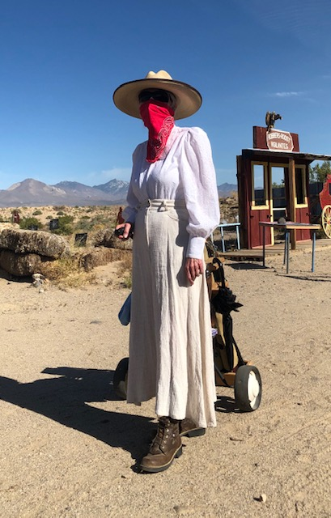

Business Card Advertising


BAD BASCOMB SASS #47,494
(aka MARI TODD)


NAME BRANDS TO SURPLUS
QUALITY CLOTHING & EQUIPMENT
FOR TRAIL OR TRAVEL
(760) 375-7223
How to Join the Robbers Roost Vigilantes…
Come out to a RRV match, held the third (and sometimes first) Saturday of every month, or call Nasty Newt at 760-375-7618, or MC Ryder at 760-384-2321, or mail it in. Our membership application is here RRV Membership Application Annual membership dues for the RRV are: single membership $25, member and spouse $30, family membership (including children under 18 living at home) $35. First time shooters will be able to take their FIRST (1) NEW SHOOTERS CLASS for $10, any subsequent new shooters class or RRV match shoot will be $10 members, $15 nonmembers. Donations for shooting regular monthly RRV matches will be $10 members, $15 non-members. Memberships run from September 1 - August 31. New memberships purchased after September will be prorated depending on the number of months remaining and the type of membership. RRV members are encouraged to become Single Action Shooting Society (SASS) members. Please call SASS at 877-411-SASS. SASS membership information can be found here:
http://www.sassnet.com/Membership-Main-001A.php

SASS membership is not required for membership in RRV, or participation in RRV regular monthly matches. RRV encourages all shooters to join and support the NRA and the NRA Foundation, and Ridgecrest Gun Range Association. For further information visit our website at www.robbersroostvigilantes.com.



Schedule of Monthly Matches
Matches are announced on the web site and via email to all club members. Cowboy matches are first and third Saturday. Trail Walks are second Saturday, and BAMM and Cowboy Rifle are fourth Saturday, when scheduled.

Summer Hours: Sign up starting ~ 7:00, Safety Meeting ~ 7:45.



