 THE VIGILANTE 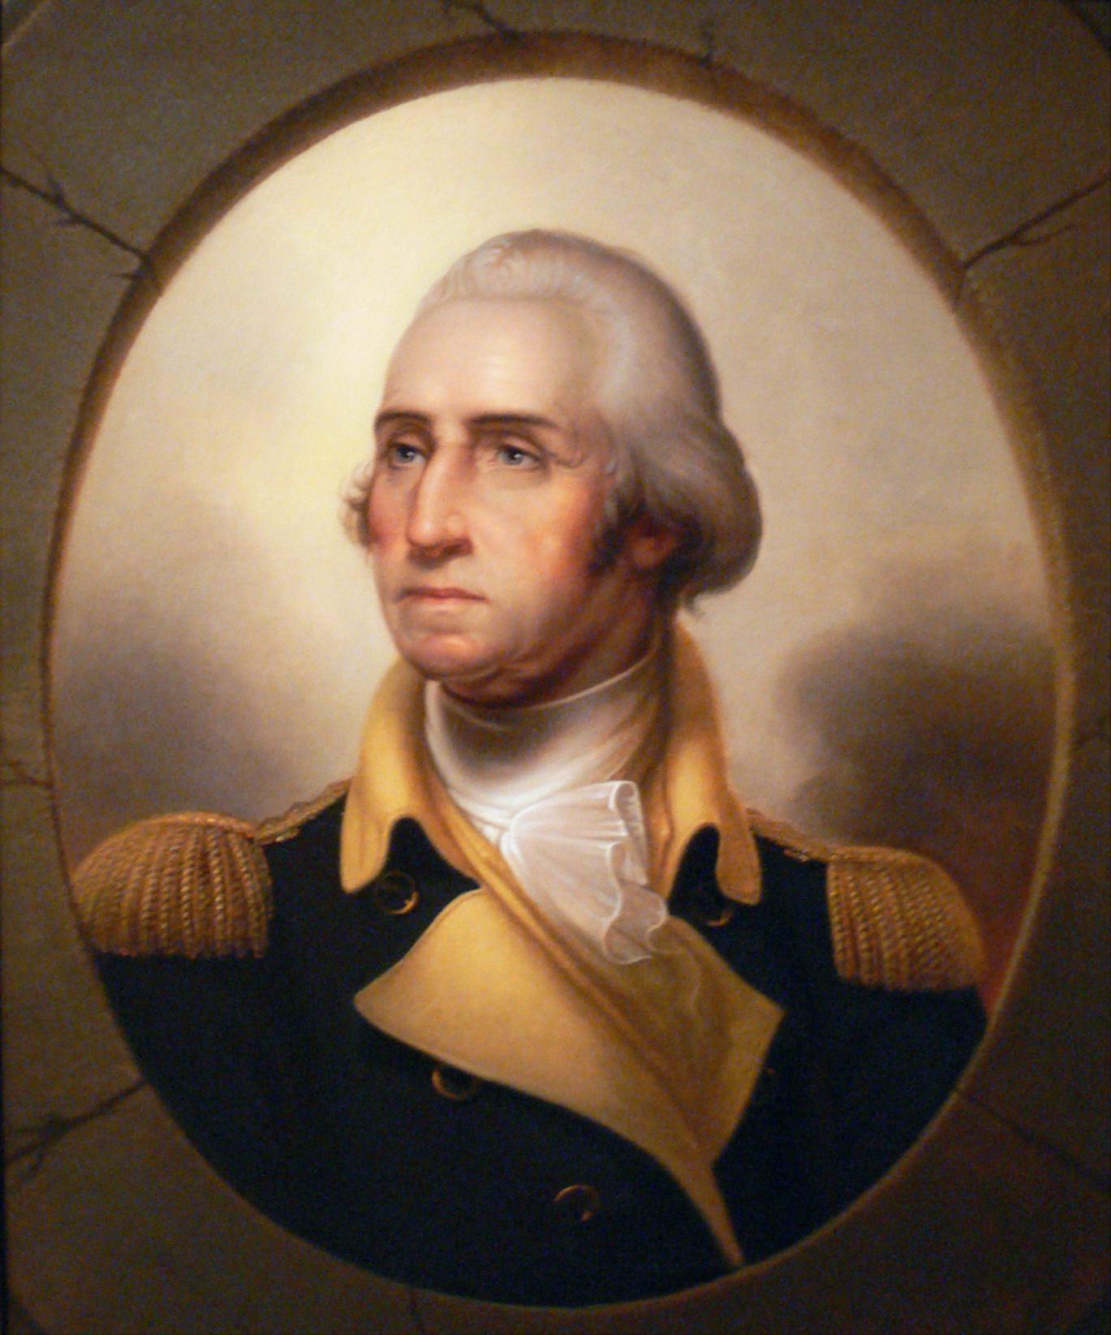
Volume 20 Issue 6 Editor: Nasty Newt SASS # 7365 February 2018

The Monthly Chronicle of the Robbers Roost Vigilantes

From the President
Another Great Month at the RRV
I believe Messrs. Washington and Lincoln would have been proud of the RRV during this, their birth month. We went out to the range and exercised our Second Amendment birthright three times, and had lots of fun doing it. True, we were down one match from January, but if we had a BAMM match every month I’d be darn near a full-time reloader. I actually enjoy reloading rifle cartridges on a single stage press, but not that much.
Twelve shooters came out on February 3rd. For a couple of stages we broke out some of the stuff we don’t use a lot, like the Texas Star, the running target, and the knockdown clay pigeon tosser. All six stages were a blast, and when it was all over Bad Bascomb, M.C. Ryder, yours truly, Orland Granger and Zig Mar were the top five. There were no clean shooters. Rusty Dover brought two new shooters, Tom Hood and Katie Hood, who is a Junior, something we don’t see a lot anymore. Welcome, you two, and don’t be strangers!
The muzzle loader trail walk on the 10th was another good one. Seven shooters came out, and when the smoke had cleared, Ed Hinkley had picked up 20 out of 23 tags. Your humble editor, always a bridesmaid and never a bride, had 19. M.C. Ryder was next with 17. Ed brought out a friend, Jerry Twohig, who shot the match. Welcome, Jerry, and come back any time! For the March trail walk, Cowboy Earl has threatened to include pistols and shotguns, so that will be a doozy. If you don’t have a muzzle-loading pistol or shotgun, there will be loaners available, so come on out. For that matter, we can fix you up with a rifle as well, so if you want to shoot a trail walk, contact me, Cowboy Earl, or M.C. Ryder.
Nine cow persons shot six more fun stages on the 17th. Bad Bascomb, M.C. Ryder, Cowboy Earl, Duelin’ Tom, and Venomous Doc were the fastest five, respectively. There were no clean shooters. Doc was making his comeback from a date with the surgeon, and we’re glad he’s back shooting again. Way to go, Doc!
Continued on page 2

Remington Arms
America’s Oldest Gunmaker
by
Nasty Newt
SASS #7365
The Remington company was founded in 1816. Eliphalet Remington II (1793–1861) believed he could build a better gun than he could buy.

Remington's father sent him to a well-known barrel maker to purchase a barrel, with the mission of observing the barrel-making technique. At the time, the method was to heat and wrap long flat bars of iron around a metal rod of the caliber desired. By heating and hammering the coiled bars around the central rod, the barrel metal became fused into a solid cylinder, at which point the rod was pressed out. This is commonly referred to as a “Damascus Twist” barrel. After the young man returned home, his family added a successful rifle barrel-making operation to his father's forge, in Ilion Gorge, New York.

That same year, young Remington began designing and building a flintlock rifle for himself. At age 23 he entered a shooting match, and although he finished second, his well-made gun impressed other contestants. Before Remington left the field that day, he had received so many orders from other competitors that he had officially entered the gun making business. By 1828, he moved his operation to nearby Ilion.

Cowboy Action Shooters and other old west aficionados are familiar with the Remington New Model Army percussion revolver, used extensively by both sides in the Civil War. The Remington 1875 and 1890 cartridge revolvers went along on the westward expansion, as did various derringers and shotguns. But perhaps the most iconic 19th century (and early 20th century, for that matter) Remington firearm was the single shot breech loading Rolling Block rifle.
Continued on page 2

INSIDE THIS EDITION
1 From the President 3 Remington Bankruptcy
1 Remington Arms Co.

2 Upcoming Events

Information
4 Where is “Why the West Was Won” ?

Remington continued from page 1
Remington Rolling Block rifles were introduced in the mid 1860’s, and were produced for more than fifty years. The action was extremely strong, and was capable of firing the most powerful black powder cartridges, as well as the smokeless powder cartridges coming into use in the 1880’s.
It was made in a variety of calibers, both rimfire and centerfire, including the 12.17x42 mm rimfire, 12.17x44 mm rimfire and 12.17x44 mm rimmed centerfire Swedish and Norwegian cartridges, .43 Spanish (11.15x58mmR), .50-70, .40-70, .45-70, and later in .22 caliber. Later models were produced in .30-06 Springfield, 7×57mm Mauser, and 8×50mmR Lebel.
The Remington Rolling Block served as the standard service rifle of the Swedish Army from 1867 to the mid-1890s (when it was replaced by the Swedish Mauser) and in Norway as the standard service rifle from 1867 to the mid-1880s (when it was replaced by the M1884 Jarmann). In .43 Spanish it was the chief service arm of the Spanish Army from 1870–1893, and was used by reserve and militia forces for many years thereafter. Many Rolling Block rifles were used by Argentina before being replaced in 1891 by the new 7.65mm Mauser, and were also widely used by Egypt and Mexico. The Remington rolling block also became the standard service rifle of the Danish Army. During the Franco-Prussian War, France acquired 210,000 Rolling Block rifles to make up for a shortage of the standard-issue Chassepot.
During World War I, the British Royal Navy purchased 4,500 Rolling Block rifles in 7mm Mauser from Remington's leftover stock after production continued below
From the President Continued from page 1

All of the scores from all three matches are posted.

In March we’re shooting cowboy matches on the 3rd and 17th, and a trail walk is planned for the 10th. We’re on Winter Hours, so we will start signups around 8:00 and try to have the meeting by 8:45.

Come on out to the range and shoot your guns. George and Abe would approve.

Robbers Roost Vigilantes
Executive Board
President
Nasty Newt
Vice President
Bad Bascomb
Secretary
Goode Bascomb
Treasurer
Desert Willow
Territorial Governor
M. C. Ryder
Range Officer/Sgt. at Arms
Cowboy Earl
Match Director Emeritus
Just George
The Robbers Roost Vigilantes Executive Board and the editor of The Vigilante are not responsible for mishaps of any nature that might occur from the use of published loading data or from the recommendations by any member of the staff, guest writers, or from products sold by advertisers.

Remington Continued from above
had ended, issuing them to the crews of minesweepers and other ships. In November 1914, production of the Rolling Block was resumed, in the form of a French contract for rifles in 8×50mmR Lebel, designated by France as "Fusil Remington modèle 1914". 100,291 such rifles were delivered by 1916, and used to equip rear-line troops.

The Rolling Block was probably used by more countries than any other rifle in history, with the possible exception of the Mauser bolt action repeater. But it was never adopted by the United States. Instead, during the single shot breech loader era, the U.S. went primarily with the Springfield Trap Door, an inferior but home grown design out of the government’s own Springfield Armory.

Along with the Sharps, the Rolling Block was one of two rifles used more than any other by the buffalo hunters who decimated the American bison herds in the 1870s and 1880s.

For further reading, see the Wikipedia articles “Remington Arms” and “Remington Rolling Block,” from which this article was largely gleaned.

ing block rifles, and later surplus military rifles, became very popular among hunters in Scandinavia, particularly for moose hunting, with ammunition for the rifles being commonly available on the civilian market into the 1920s-1930s.

Business Card Advertising


BAD BASCOMB SASS #47,494
(aka MARI TODD)


NAME BRANDS TO SURPLUS
QUALITY CLOTHING & EQUIPMENT
FOR TRAIL OR TRAVEL
(760) 375-7223
How to Join the Robbers Roost Vigilantes…
Come out to a RRV match, held the third (and sometimes first) Saturday of every month, or call Nasty Newt at 760-375-7618, or MC Ryder at 760-384-2321, or mail it in. Our membership application is here RRV Membership Application Annual membership dues for the RRV are: single membership $25, member and spouse $30, family membership (including children under 18 living at home) $35. First time shooters will be able to take their FIRST (1) NEW SHOOTERS CLASS for $10, any subsequent new shooters class or RRV match shoot will be $10 members, $15 nonmembers. Donations for shooting regular monthly RRV matches will be $10 members, $15 non-members. Memberships run from September 1 - August 31. New memberships purchased after September will be prorated depending on the number of months remaining and the type of membership. RRV members are encouraged to become Single Action Shooting Society (SASS) members. Please call SASS at 877-411-SASS. SASS membership information can be found here:
http://www.sassnet.com/Membership-Main-001A.php

SASS membership is not required for membership in RRV, or participation in RRV regular monthly matches. RRV encourages all shooters to join and support the NRA and the NRA Foundation, and Ridgecrest Gun Range Association. For further information visit our website at www.robbersroostvigilantes.com.



Schedule of Monthly Matches
RRV Match Dates:
Mar 3, 2018 Cowboy
Mar 10, 2018 Trail Walk
Mar 17, 2018 Cowboy

Winter Hours: Sign up starting ~ 8:00, Safety Meeting ~ 8:45.

The Bankruptcy of Remington Arms
by Duelin’ Tom, GUNS4US, SASS # 20080, RRV # 16
Remington Arms files for bankruptcy. This is the talk floating around right now. Yes, they have filed for bankruptcy, but it’s a reorganizational bankruptcy, meaning they intend and expect to stay in business. But the reason they state is a reverse of normal problems. They cite that with President Trump in office, people are in no hurry to buy guns because they don’t think there will be any real anti-gun legislation passed while Trump is in office. Under President Obama, people were “surge buying” in order to get their guns before any new ban.
So, that is Remington’s theory, and it is true, as far as it goes. But I have to say that since the company was taken over by a finance group, there have also been some mistakes in production that seriously damaged the brand. By now everyone knows the major blunder they made when they purchased Marlin. When they started producing their lever actions, they had a lot of problems, even recalls. And to date they still aren’t back on track. Under Remington, only part of the Marlin line has been manufactured to date.
In addition to the Marlin debacle, Remington’s expansion into the very heavy AR and 1911 markets was ill-timed and difficult. There are so many manufacturers of those type guns now that it is extremely competitive, and mostly driven by cost.
I believe Remington will come out of this OK, hopefully with the Marlin production glitches fixed. We don’t need to lose a manufacturer like Remington.
Finally, I can’t begin to imagine what will happen to the whole firearms industry if Congress bans ALL AR style guns. Stand by for chaos.

