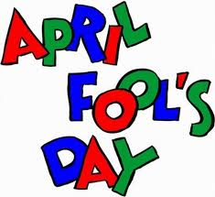 THE VIGILANTE 

Volume 19 Issue 8 Editor: Nasty Newt SASS # 7365 April 2017

##### The Monthly Chronicle of the Robbers Roost Vigilantes

From The President

**There’s Lots to Love in April**

On April 1, several April Fools and a few unspecified types rushed in for our first Saturday match. Fools and their cartridges were soon parted, there was some foolin’ around at the saloon, and we were fooled not once, but twice, proving there’s no fool like an old cowboy. It may have been a fool’s errand, but we had fun doing it. When all the foolishness was completed, the standings shaped up this way: Bad Bascomb, Zig Mar, Nasty Newt, Wrangler Red, Goode Bascomb, Rum Runner, and Silver Badger. Wrangler Red shot the match clean.

On the 8th Cowboy Earl set up another one of his great muzzle loader Trail Walks, and added some black powder shotgun shots to the mix. Not everybody has one of those, so Cowboy Earl and M.C. Ryder were happy to share their guns. It was a windy day, and the clay pigeons that were launched pretty quickly turned around and headed back toward the shooter! The score sheet isn’t available at press time, but we’re pretty sure the top three shooters were Ed Hinkley, M.C. Ryder, and Cowboy Earl.

Speaking of muzzle loading shotguns, I watched a couple of YouTube videos and decided to try to turn my .50 caliber rifle into a shotgun. The guys on the videos were either a lot better at it than me, or were lying. They managed to shoot pretty good patterns, but I only got 14 pellets on about a 12 x 12 inch shoe box at 25 paces, out of ¾ oz. of #6 shot. So much for that. I will borrow a shotgun from M.C. or Cowboy Earl.

For the 15th, we knew that a lot of our regular shooters would be unable to shoot for one reason or another. In my case, I was going to be in Colorado, and my guns won’t shoot that far. Anyway, M. C. Ryder said that if enough people wanted to shoot to make a posse, he would put on the match. Rusty Dover called and said he and Belle E. Button would really like to come over from Lancaster and shoot it possible, and M.C. said “Okay, it’s on.” Six shooters came out and had a great time. You can only do it with six people if everybody chips in and does their share, and guess what, everybody did. *Continued on page 2*

**Baseball in the Wild West**

From an article by Gregory Lalire,

*Wild West* magazine, 3/31/2011

The history of baseball is sketchy, at best, but one thing is certain: Future Civil War Union General Abner Doubleday did *not* invent baseball in Cooperstown, N.Y., in 1839—a myth not only accepted but also promoted by Major League Baseball for many years. Truth is, no one “invented” baseball. Europeans were playing stick-and-ball games centuries before there was a United States, and those games came across the Atlantic with immigrants. In the 1820s and 1830s folks in Philadelphia, New York and New England were playing several variations of “base ball” (originally spelled as two words). In 1845 Alexander Joy Cartwright Jr. was among the organizers of the Knickerbocker Base Ball Club, which played first in Manhattan and then across the Hudson River at the Elysian Fields, outside Hoboken, N.J. Cartwright and associates published a set of rules and regulations that became the foundation of modern baseball.

During the Civil War, soldiers—mostly Yankees, though some Rebels—played baseball during battlefield lulls and in prison camps. Union soldier George Putnam recalled that once during a baseball game in Alexandria, La., enemy troops attacked, placing the outfielders in mortal danger. The left fielder and right fielder managed to get back to the dugout, but the Rebels shot and captured the center fielder before the Yankees could repel the attack.

In 1869 the Cincinnati Red Stockings became the first true professional baseball team, its players drawing salaries (the high being $1,400 a season to George Wright, the brother of player-manager Harry Wright). That first season the Red Stockings posted a perfect 57–0 record against generally overmatched amateur teams.

*Continued on page 2*

**INSIDE THIS EDITION**

**1**  From the President **3** RRV Match Schedule

**1** Baseball Out West

**2** Happy Trails, Papa

**2** Upcoming Events

Information

**4** Where is “Why the West Was Won” ?

***From the President*** *Continued from page 1*

The order of finish was M. C. Ryder, Zig Mar, Cowboy Earl, Rusty Dover, Silver Badger, and Belle E. Button.

In May, we will have Cowboy matches on the 6th and 20th, a black powder muzzle loader Trail Walk on the 13th, and a BAMM match on the 27th. We have switched to Summer Hours, and we will start signing up around 7:00.

Get yourself out to the range and have some fun!

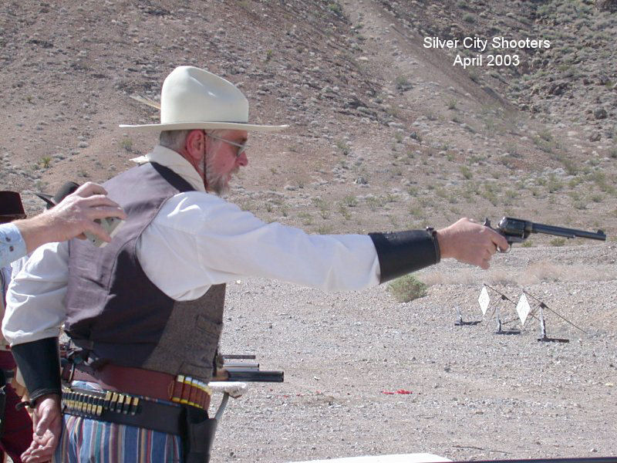

Ken Bolling, aka *Papa*

*7/19/47 – 4/24/17*

“I always enjoyed shooting with Papa, even the time he had an AD with his 1911 and shot the Flying Pig’s cable in two on The Great Train Robbery.” *Nasty Newt*

“I remember talking to him and his wife at one of our annual shoots here. He was a great shooter and a real SASS cowboy. He'll be missed.” *Duelin Tom*

“Papa was a wonderful help when I was just learning to "cowboy up". He and Mema are the type who share knowledge and friendship - treasures in the sport.”

*Sadly, Death Valley Rose & Wrangler Red*

“Very Sorry to hear about Papa. My condolences.” *Rusty Dover*

“Very Sad.” *Just George*

**Robbers Roost Vigilantes**

**Executive Board**

President

**Nasty Newt**

Vice President

**Bad Bascomb**

Secretary

**Goode Bascomb**

Treasurer

**Desert Willow**

Territorial Governor

**M. C. Ryder**

Range Officer/Sgt. at Arms

**Cowboy Earl**

Match Director Emeritus

**Just George**

The Robbers Roost Vigilantes Executive Board and the editor of *The Vigilante* are not responsible for mishaps of any nature that might occur from the use of published loading data or from the recommendations by any member of the staff, guest writers, or from products sold by advertisers.

Baseball *continued from page 1*

In 1873, H Company, 7th U.S. Cavalry, formed the Benteen Base Ball Club, named in honor of company commander Captain Frederick Benteen. While in Dakota Territory between 1873 and 1876, the club played other military squads as well as civilian teams. On July 31, 1874, during Lt. Col. George Custer’s Black Hills Expedition, the Fort Lincoln Actives defeated the Fort Rice Athletes, 11–6, at the site of what is now Custer, S.D.

Many towns and forts—including Fort Union in New Mexico Territory, Fort Apache in Arizona Territory, Fort Russell in Wyoming Territory and Fort Missoula in Montana—proudly formed teams in the closing decades of the 19th century. At Fort Sill in Indian Territory (present-day Oklahoma), where baseball made its appearance as early as the 1870s, Indians sometimes played alongside soldiers, although its most famous internee, Apache leader Geronimo, favored racing his horse over watching baseball.

In 1875 the Mississippi River town of Keokuk, Iowa, fielded a team in the National Association of Professional Baseball Players. The National Association became the National League the next year, but the Keokuk Westerns did not become a part of it. In 1876 (the same year Custer met his match at the Little Bighorn in Montana Territory and drifter Jack McCall shot Hickok from behind in Deadwood, Dakota Territory) only one of the original eight National League teams—the St. Louis Brown Stockings—was from the West, joining teams from New York, Boston, Philadelphia, Chicago, Cincinnati, Hartford and Louisville.

*Continued on page 3*

**Business Card Advertising**



BAD BASCOMB SASS #47,494

(aka MARI TODD)

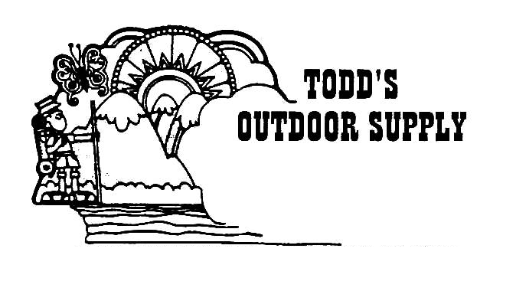

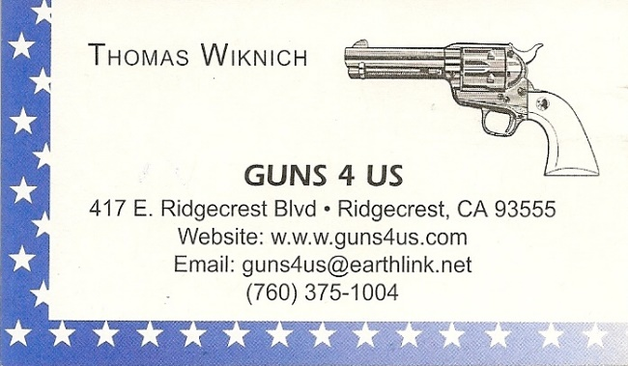

**NAME BRANDS TO SURPLUS**

*QUALITY CLOTHING & EQUIPMENT*

*FOR TRAIL OR TRAVEL*

**(760) 375-7223**

How to Join the Robbers Roost Vigilantes…

Come out to a RRV match, held the third (and sometimes first) Saturday of every month, or call Nasty Newt at 760-375-7618, or MC Ryder at 760-384-2321, or mail it in. Our membership application is here [**RRV Membership Application**](http://www.robbersroostvigilantes.com/MembershipApplication.doc)Annual membership dues for the RRV are: single membership $25, member and spouse $30, family membership (including children under 18 living at home) $35. First time shooters will be able to take their FIRST (1) NEW SHOOTERS CLASS for $10, any subsequent new shooters class or RRV match shoot will be $10 members, $15 nonmembers. Donations for shooting regular monthly RRV matches will be $10 members, $15 non-members. Memberships run from September 1 - August 31. New memberships purchased after September will be prorated depending on the number of months remaining and the type of membership. **RRV members are encouraged to become Single Action Shooting Society (SASS) members**. Please call SASS at **877-411-SASS**. SASS membership information can be found here:

[http://www.sassnet.com/Membership-Main-001A.php](http://www.sassnet.com/Membership-Main-001A.php%20%20)

SASS membership is not required for membership in RRV, or participation in RRV regular monthly matches**. RRV encourages all shooters to join and support the NRA and the NRA Foundation, and Ridgecrest Gun Range Association.** For further information visit our website at [www.robbersroostvigilantes.com](http://www.robbersroostvigilantes.com).



Baseball *continued from page 2*

Over in New Mexico Territory in 1880, the first semipro team in Albuquerque took the field on the fairgrounds. Baseball also took root during Arizona’s territorial days. Around Tombstone in 1882, the same year Wyatt Earp carried out his vendetta against the Cowboys, a civil engineer from Massachusetts named George S. Rice had baseball on his mind. First, he started a team called the San Pedro Boys at his Boston and Arizona Mill, following that up with the Tombstone Base Ball Association squad. After much practice, his “tossers” opened their season on May 12 with a loss to a Tucson club, but the organization was persistent, playing ball for four decades.

In the Far West, the semipro California League and the original Pacific Coast League launched in the 1870s. It wasn’t until 1958 that modern-day Major League Baseball teams operated west of St. Louis—after the Brooklyn Dodgers moved to Los Angeles and the New York Giants to San Francisco. Today the Far West is also home to the Los Angeles Angels, Oakland Athletics, San Diego Padres and Seattle Mariners.

*The End*

**Schedule of Monthly Matches**

**RRV Match Dates:**

**May 6, 2017 Cowboy**

**May 13, 2017 Trail Walk**

**May 20, 2017 Cowboy**

**May 27, 2017 BAMM**

**Summer Hours: Sign up starting ~ 7:00, Safety Meeting ~ 7:45.**