THE VIGILANTE 
Volume 15 Issue 1 Editor: Nasty Newt SASS # 7365 September 2012

The Monthly Chronicle of the Robbers Roost Vigilantes

From The President
Summer Goes Out in Style at
RRV September Match
It was a nice end-of-summer kind of day, and we even had an end-of-summer sale. As I’m sure most of you know, anybody that paid their club dues no later than the day of our September match had a free shoot coming, and several shooters used it for this match. If you haven’t paid your dues yet you’re out of luck for the free shoot, but a dues-paying club member can shoot for $10 instead of paying the $15 non-member fee, so you’ll get your money back pretty quick.
MC Ryder wrote the stages for our September match. He said he wanted to try out some things he’d seen at other clubs, and we had a blast. Some of the scenarios seemed tougher at first blush than they really were—once the pattern sunk in and the light came on, it turned out they were challenging but not hard, and a lot of fun. One stage offered the shooter an option of moving left or right to shoot the second gun, and the line was, “Which way did they go?” Speaking of lines, MC was considerate of the memory impaired: for some stages the shooter was instructed to signify ready by saying, “I’m ready.” But yes, there were some who couldn’t remember the line.
15 shooters turned out. Venomous Doc liked the stages, and shot them almost 40 seconds faster than anybody else. Yours truly, MC Ryder, Harvey Mushman and Utah Blaine rounded out the top five. Ball N. Chain was the top lady shooter on the day, dressed to the nines as a dance hall girl. Tank shot the match clean.
This match marked the return to the range of one of the founding members of the RRV, Gimpy Gus. Back in 1998, five of us threw some money in the pot and said, “Let’s see if we can do this.” Well, we did it, and Gus shot regularly for years, then got sidelined by physical problems. He wanted to get back out there, and I sure hope he can continue. He shot three stages before calling it off, which is a pretty good start after such a long layoff. Welcome back, Gimpy Gus!
continued on page 2

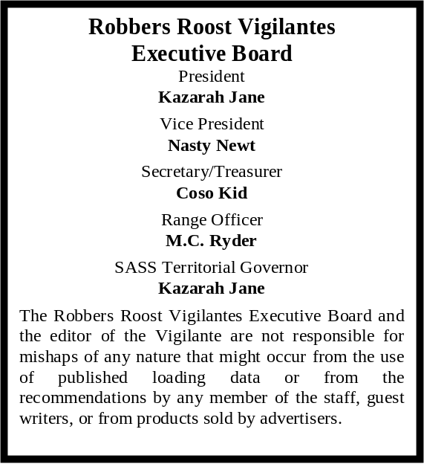

The Wild West Lives on Even After
The RRV Monthly Shoot
By
Ball N. Chain, SASS # 88449

Cowboy action excitement continued in Randsburg on September 15. After our monthly shoot, Buckhorn Bud and I traveled to Randsburg, about 30 minutes south of Ridgecrest, to attend their annual Wild West Days.
There were thousands of people in attendance.
Buckhorn Bud and I felt like we had stepped back in time for a wonderful day filled with reenacted gun fights, great food, vendors, cowboys directly from the range, dance shows, live bands and of course the saloons that the wild west was famous for.
I had never been on a horse in my life. Bud asked the cowboys if I could ride a horse to complete an item on my “bucket list.” Well, according to Buckhorn Bud, they were more than happy to oblige. Even though we had spent some time in the saloon earlier, I was still a little nervous. But the next thing I knew, I was in the saddle. It was a lot of fun, and riding a horse is officially scratched off my list! There’s photographic proof on page 2.
Buckhorn Bud danced with his 4 year old Granddaughter Aurora. His heart melted when she asked him to dance, and who could refuse? Certainly not Bud. See the picture on page 2.
We also met up with some interesting hombres. In the photo on page 3, the man (third from the left) is Robert Duvall’s stunt double and the cowboy on the right is “Virgil” an actor from our local thespian cowboy group. They present a wonderful live performance of the Tombstone gunfight; shooting blanks, of course.
If you did not get the opportunity to go this year, this event is always held the day of our third Saturday shoot in September. Next year, stay in your cowboy duds and wagon on up to Randsburg after the shoot. You won’t regret it. Happy trails!

INSIDE THIS EDITION
1 From the President 3 RRV Match Schedule
1 Randsburg Wild West Days
2 Upcoming Events
2 - 3 Randsburg Wild West Days Photos
2 Upcoming Events

Infornation
4 Where is “Why the West Was Won” ?

We’re shooting the first Saturday in October, the 6th. We’ll also be out there on the third Saturday, the 20th. We’re now on regular hours, which means sign ups start around 8:00, with the safety meeting at about 8:45. The new shooter class would get underway around 7:30. If you know of a new shooter that’s coming out, be sure to let Bad Bascomb or MC Ryder know so we can be prepared.
No breakfast on the 6th. Whether or not breakfast will be served on the 20th has not yet been determined, but will be announced prior to the match.
UPCOMING EVENTS
Monthly shoots:
The Cajon Cowboys shoot on the: 2nd (club day) and 4th (open shoot) Saturdays of each month at the Gem Ranch in the Cajon Pass on old route 66. Contact Luke Warmwater at (909) 987-7017.
Five Dogs Creek Cowboys in Bakersfield shoot on the 1st weekend of each month. Call Dirt McFearson, (661) 805-3281.

High Desert Cowboys shoot in Acton on the 3rd Sunday. Contact Doc Silverhawks, (661) 948-2543.

Double R Bar Regulators, Lucerne Valley, shoot the 2nd Sunday. Call Five Jacks, (951) 347-0862. They host the SASS Western Regional Last Stand at Chimney Rock, October 11-14.

Lone Wolf Shooters, Pahrump, NV, shoot the 2^{nd,} 4th and 5th Sunday. Call Lash Latigo or Penny Pepperbox, (775) 727-4600 days, (775) 727-8790 evenings. They host Wild West Extravaganza October 11 - 12, and the Nevada State Wild Bunch Championship November 10 - 11. Contact pennypepperbox@yahoo.com.

El Dorado Cowboys, Boulder City, NV, shoot the 1st weekend (Sat & Sun). Contact Charming at 702-565-3736, or Boxherder at 702-858-6396.
www.eldoradocowboys.com. They host the Nevada State Championship, El Dorado, October 4 - 7.

The Bridgeport Vigilantes have canceled their season and hope to resume shooting next May.
Continued from Page 1

Robbers Roost Vigilantes
Executive Board
President
Nasty Newt
Vice President
Bad Bascomb
Secretary
Goode Bascomb
Treasurer
Desert Willow
Territorial Governor
M. C. Ryder
Range Officer/Sgt. at Arms/Match Director
Just George
The Robbers Roost Vigilantes Executive Board and the editor of The Vigilante are not responsible for mishaps of any nature that might occur from the use of published loading data or from the recommendations by any member of the staff, guest writers, or from products sold by advertisers.

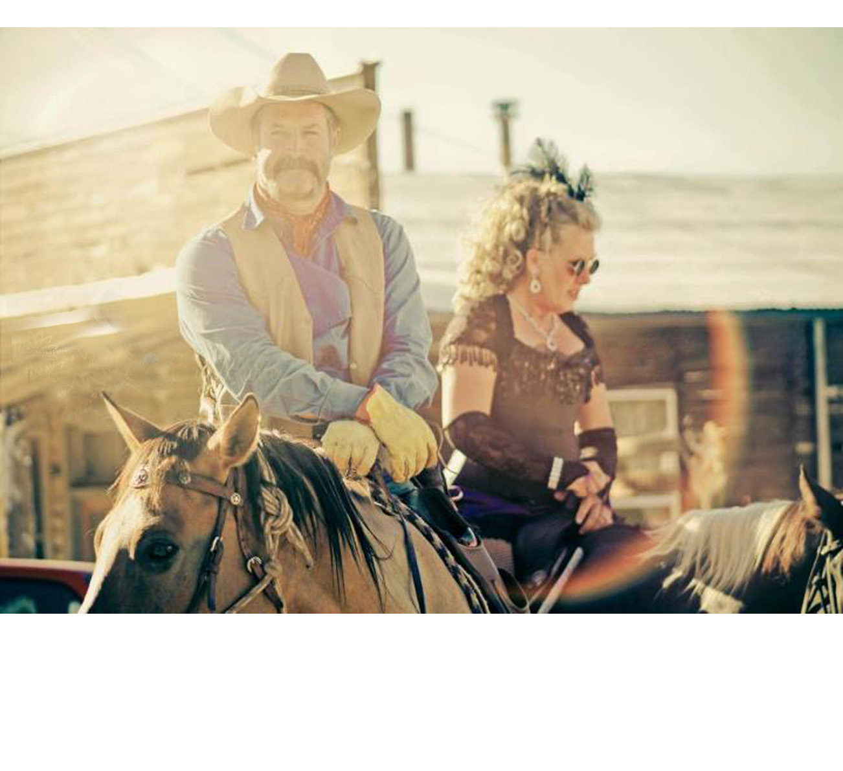

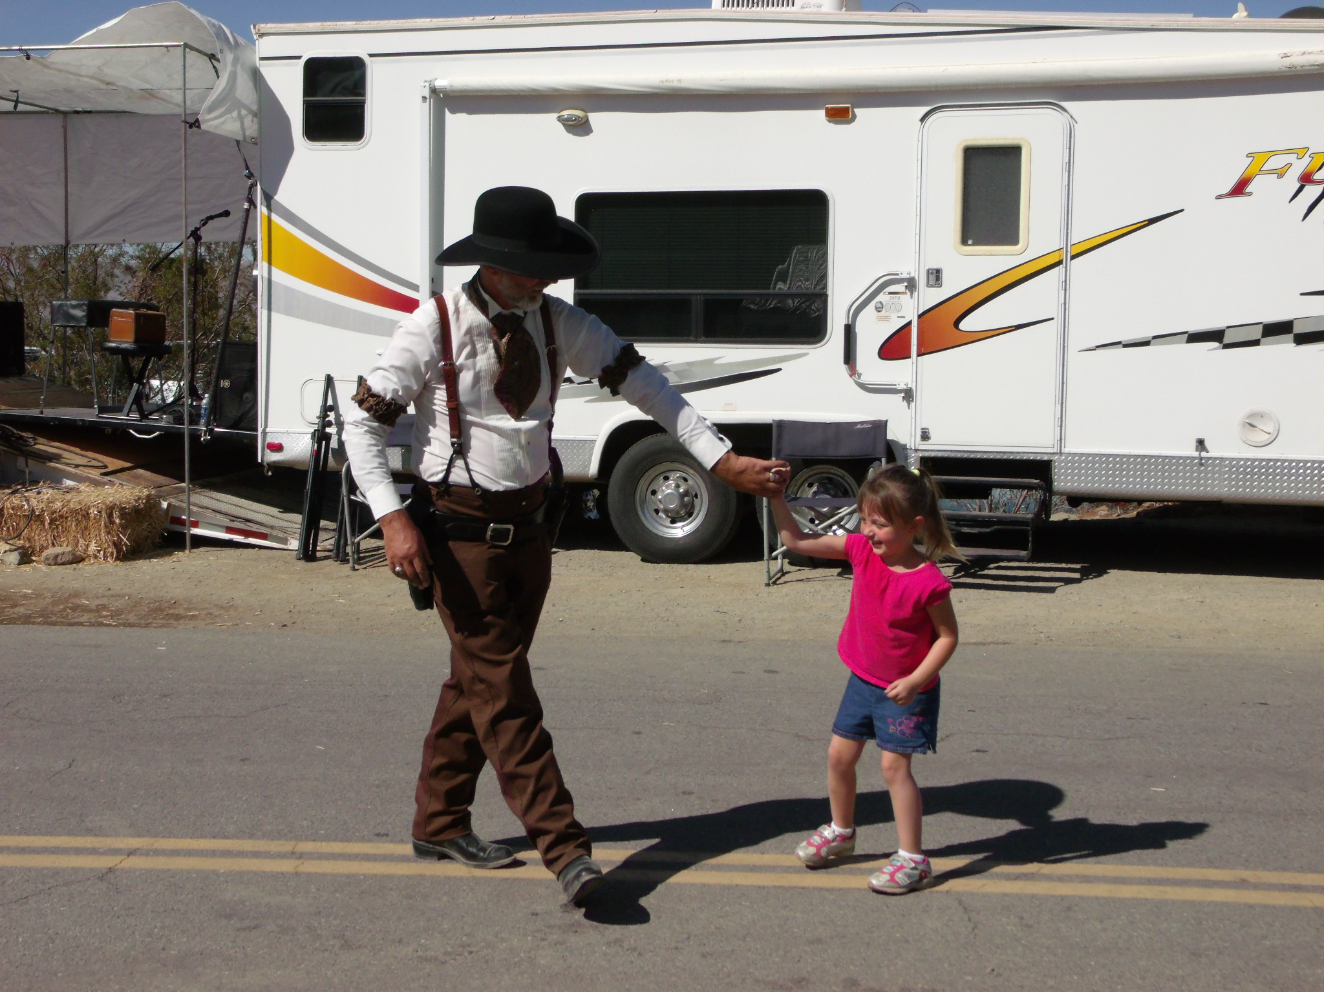

Business Card Advertising


BAD BASCOMB SASS #47,494
(aka MARI TODD)

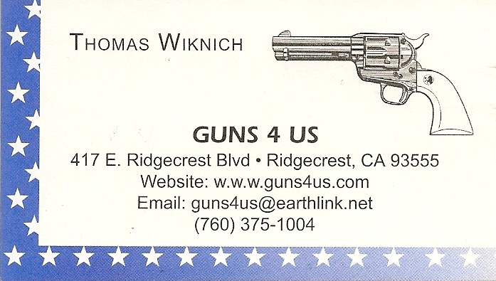

NAME BRANDS TO SURPLUS
QUALITY CLOTHING & EQUIPMENT
FOR TRAIL OR TRAVEL
(760) 375-7223

425 W RIDGECREST BLVD.  RIDGECREST, CA 93555


COLLINS GUNSMITHING
MODERN ANTIQUE REPLICA
ACTION JOBS BLUEING STOCK WORK
FOR ALL YOUR REPAIRS AND SERVICE
760-375-5703

“Whiskey is for drinking.
Water is for fighting over.”

Possibly Mark Twain,
but unknown

How to Join the Robbers Roost Vigilantes…

Come out to a RRV match, held the third (and sometimes first) Saturday of every month, or call Nasty Newt at 760-375-7618, or MC Ryder at 760-384-2321, or mail it in. Our membership application is here RRV Membership Application Annual membership dues for the RRV are: single membership $25, member and spouse $30, family membership (including children under 18 living at home) $35. First time shooters will be able to take their FIRST (1) NEW SHOOTERS CLASS for $10, any subsequent new shooters class or RRV match shoot will be $10 members, $15 non members. Donations for shooting regular monthly RRV matches will be $10 members, $15 non-members. Memberships run from September 1 - August 31. New memberships purchased after September will be prorated depending on the number of months remaining and the type of membership. RRV members are encouraged to become Single Action Shooting Society (SASS) members. Please call SASS at (505) 843-1320, or go to www. sassnet.com. SASS first year single initiation membership is $55, renewal for single membership is $45. As part of your SASS membership you will receive The Cowboy Chronicle (12 issues/year), registration of your alias, a SASS badge with your SASS number on it, a membership certificate and membership card, a SASS Marshall lapel pin, and SASS Shooters Handbook. SASS membership is not required for membership in RRV, or participation in RRV regular monthly matches. RRV encourages all shooters to join and support the NRA and the NRA Foundation, and Ridgecrest Gun Range Association. For further information visit our website at www.robbersroostvigilantes.com.

Schedule of Monthly Matches
RRV Match Dates:
October 6, 2012.
October 20, 2012
Regulars Hours: Sign up starting
~ 8:00, Safety Meeting ~ 8:45.

New Shooter Class ~ 7:30.
Breakfast to be determined.



