THE VIGILANTE
Volume 14 Issue 3 Editor: Nasty Newt SASS # 7365 November 2011

The Monthly Chronicle of the Robbers Roost Vigilantes

From The President
A Vigilante Thanksgiving
Twenty-two Vigilantes turned out for our November match on a beautiful fall day. After a great breakfast served up fresh and hot, they loaded up the guns and went out hunting for their Thanksgiving turkey, but Murphy being the rascal he is, he applied “the law” and things kinda started going downhill.
Turkeys are few and far between in the desert around Crumville, but the Vigilantes figgered they ought to shoot something, so they asked the birds to step forward and volunteer, with predictable results.
A home cooked meal being out of the question, they repaired to the hotel for dinner, only to be served up the worst Thanksgiving meal this side of a Civil War prisoner of war camp. Turkey vulture and turkey ain’t the same thing, no matter what the cook at the hotel says.
With the idea of a holiday feast totally abandoned, the Vigilantes re-grouped in the saloon, hoping to at least be able to drown their sorrows in peace, but the bartender had other ideas and rendered the final insult of the day by pouring short drinks. As you might suspect, guns were drawn and shots were fired.
Soledad, shooting 49’er, shot his way to the top of the heap. Justin O Sheriff, Bad Bascomb, Marshal Phil Degrave, and Ozark Lawdog rounded out the top 5. Ladies Silver Senior Goode Bascomb was the top lady on the day. Wrangler Red and Justin O Sheriff shot the match clean. Congratulations, everyone! All of the scores are posted.
The air was full of smoke, with no fewer than five shooters burning charcoal. There were three (count ‘em, three) Frontier Cartridge Gunfighters, one Frontier Cartridge, and one Frontiersman.
Marshal Phil DeGrave picked up his Dillon RL550 and the (not so cowboy) .223 dies he requested. Congrats, Marshal, and thanks for your support of our fundraiser.
continued on page 2

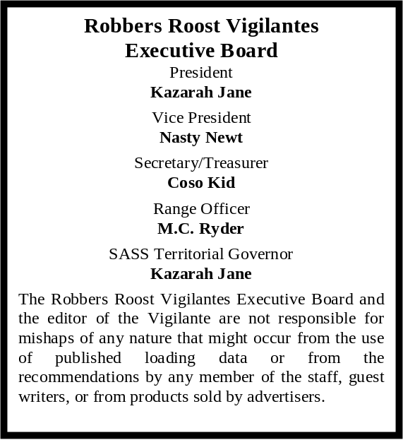

The SASS 2012 California State Black Powder Shootout at Defend the Roost
and the
Smokeless Powder Resurrection
May 17 – 20, 2012

Well, that was a mouthful, but it all pretty much needs to be in there to describe what we’re doing. The October time frame that we slipped DTR into this year was a one-time shot. RRBAR had moved the Western Regional to November to coincide with Roy Rogers’ birthday, and they’ve already announced that next year they’re going back to October. Since we’re all gunshy about November, we’re rolling DTR, Resurrection, and the State BP Shootout into one match, and doing it in May.

The match will be run the way we’ve done Resurrection and the BP Shootout in the past. Posses will have both BP and smokeless shooters, but the BP and smokeless matches will be scored separately. We’ll have all the DTR trappings—including the tent, lunches, pot lucks, vendors, awards banquet on the range, the Yelping Coyote, and side matches galore, including The Great Train Robbery and The Professionals, which we used to call Wild Bunch, but can’t anymore because of confusion regarding the SASS sanctioned side match called Wild Bunch.

We’re going to upgrade the awards for first place in all categories, both BP and smokeless, and we’ll present the Skeeter Oly Perpetual Clean Shoot Trophy.

We will only be putting on one annual match this year, and this is it, so we’re pulling out all the stops. Every year we ask you to sign up early for Defend the Roost, and this time is no exception, although there’s maybe a little more urgency attached due to the compressed time frame. The application is on-line at
www.robbersroostvigilantes.com. See you there!

INSIDE THIS EDITION
1 From the President 3 RRV Match Schedule
1 DTR 2012
2 RRV Invades SASS Western Regional
2 Upcoming Events

Infornation
4 Where is “Why the West Was Won” ?

The next match is December 17th, winter hours, which means sign-ups at about 8:00, and shooter meeting around 8:45. A sumptuous breakfast of biscuits and gravy, sausage, scrambled eggs, OJ and coffee will be served from roughly 7:30 to 8:30, for the princely sum of five bucks!

Anyone wishing to take the new shooter class should be at the range by 7:30. As always, we request advance notice if someone wants to take the class so we can be prepared.
UPCOMING EVENTS
Monthly shoots:
The Cajon Cowboys shoot on the: 2nd (club day) and 4th (open shoot) Saturdays of each month at the Gem Ranch in the Cajon Pass on old route 66. Contact Luke Warmwater at (909) 987-7017.
Five Dogs Creek Cowboys in Bakersfield shoot on the 1st weekend of each month. Call Dirt McFearson, (661) 805-3281.

High Desert Cowboys shoot in Acton on the 3rd Sunday. Contact Doc Silverhawks, (661) 948-2543.

Double R Bar Regulators, Lucerne Valley, shoot the 2nd Sunday. Call Five Jacks, (951) 347-0862.

Silver City Shooting Society shoots at Pahrump, NV, 4th Sunday. Call Philly Slim, (775) 764-0257. www.silvercityshootingsociety.com.

Lone Wolf Shooters, Pahrump, NV, shoot the 2nd weekend. Call Lash Latigo or Penny Pepperbox, (775) 727-4600 days, (775) 727-8790 evenings.

El Dorado Cowboys, Boulder City, NV, shoot the 1st weekend (Sat & Sun). Contact Charming at 702-565-3736, or Boxherder at 702-858-6396.
www.eldoradocowboys.com.

Continued from Page 1

Robbers Roost Vigilantes
Executive Board
President
Nasty Newt
Vice President
Bad Bascomb
Secretary
Goode Bascomb
Treasurer
Desert Willow
Territorial Governor
M. C. Ryder
Range Officer/Sgt. at Arms/Match Director
Just George
The Robbers Roost Vigilantes Executive Board and the editor of The Vigilante are not responsible for mishaps of any nature that might occur from the use of published loading data or from the recommendations by any member of the staff, guest writers, or from products sold by advertisers.
Robbers Roost Vigilantes Invade SASS Western Regional
No fewer than ten Vigilantes, or about 20% of our club, attended the Last Stand at Chimney Rock. I doubt that any club other than RRBAR can make that claim.
In order of overall finish they are: Venomous Doc, 7th place Senior; Bad Bascomb, 4th place Frontier Cartridge; Ozark Lawdog, 9th place Senior; Cowboy Earl, 3rd place Frontiersman; MC Ryder, 7th place B Western; Buckhorn Bud, 4th place Frontiersman; Harvey Mushman, 4th place Senior Duelist; Goode Bascomb, 3rd place Lady Frontier Cartridge; Ball N. Chain, 4th place Lady Wrangler; and Bodie Kid, 9th place Elder Statesman.
Bad Bascomb won the Speed Shotgun – 87 side match, and Venomous Doc came in first in Speed Derringer.
In the costume contests Ball N. Chain won 1st place Soiled Dove, and 3rd place Lady; Buckhorn Bud got 3rd place Huckleberry; and Bodie Kid, 2nd place Classic Cowboy.
And last but certainly not least, Bodie Kid, who hasn’t been well lately, won the Spirit of the Game award for hanging in there and shooting all twelve stages, against all odds. Bodie and Bee Blest are a great team, and we’ll be seeing them around the range for a long time to come.
Congratulations to one and all. You guys and gals done us proud!

Business Card Advertising $24 for 12 Issues


BAD BASCOMB SASS #47,494
(aka MARI TODD)

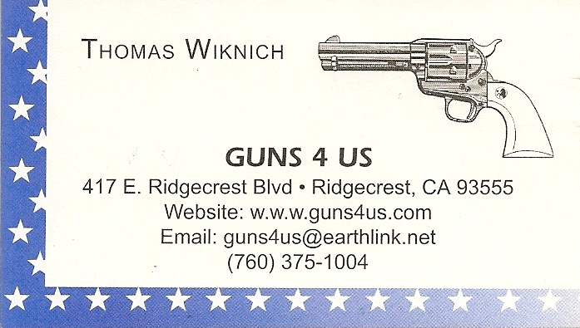

NAME BRANDS TO SURPLUS
QUALITY CLOTHING & EQUIPMENT
FOR TRAIL OR TRAVEL
(760) 375-7223

425 W RIDGECREST BLVD.  RIDGECREST, CA 93555


COLLINS GUNSMITHING
MODERN ANTIQUE REPLICA
ACTION JOBS BLUEING STOCK WORK
FOR ALL YOUR REPAIRS AND SERVICE
760-375-5703
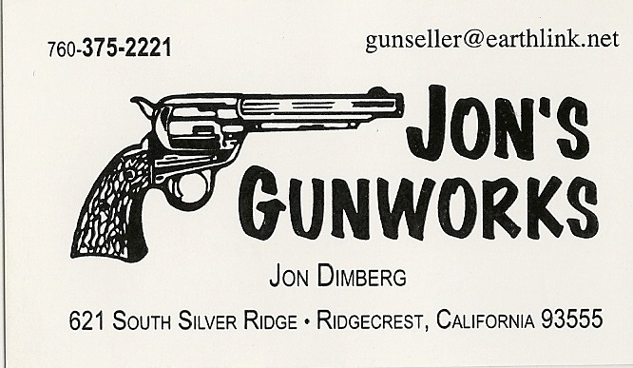

Schedule of Monthly Matches
RRV Match Dates:

Winter hours: Sign-up ~ 8:00, meeting ~ 8:45. Breakfast 7:30 to 8:30. New shooter class at 7:30

December 17, 2011.

How to Join the Robbers Roost Vigilantes…

Come out to a RRV match, held the third Saturday of every month, or call Nasty Newt at 760-375-7618, or MC Ryder at 760-384-2321. Annual membership dues for the RRV are: single membership $25, member and spouse $30, family membership (including children under 18 living at home) $35. First time shooters will be able to take their FIRST (1) NEW SHOOTERS CLASS for $10, any subsequent new shooters class or RRV match shoot will be $10 members, $15 non members. Donations for shooting regular monthly RRV matches will be $10 members, $15 non-members. Memberships run from September 1 August 31. New memberships purchased after September will be prorated depending on the number of months remaining and the type of membership. RRV members are encouraged to become Single Action Shooting Society (SASS) members. Please call SASS at (505) 843-1320, or go to www. sassnet.com. SASS first year single initiation membership is $55, renewal for single membership is $45. As part of your SASS membership you will receive The Cowboy Chronicle (12 issues/year), registration of your alias, a SASS badge with your SASS number on it, a membership certificate and membership card, a SASS Marshall lapel pin, and SASS Shooters Handbook. SASS membership is not required for membership in RRV, or participation in RRV regular monthly matches. RRV encourages all shooters to join and support the NRA and the NRA Foundation, and Ridgecrest Gun Range Association. For further information visit our website at www.robbersroostvigilantes.com.



